In order for you and your teachers to get the most out of TEAMS we need you to update to the most current version. Teams updates are per-machine and per user, so this will need to be done individually on each device you use.
This is the old version of TEAMS that you might be running:
To update the App:
Log in to TEAMS
Click on your initials at the top right hand corner of Teams:
Scroll down and click Sign Out
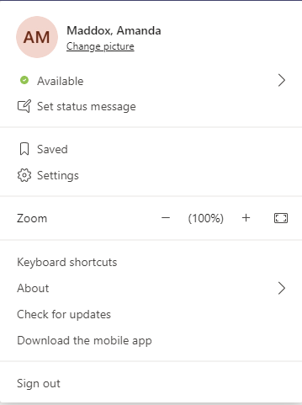

Teams will close and re-open.
Log back in – you should now have the updated version
If this does not work, you might get an ‘Update in 28 days’ warning message:
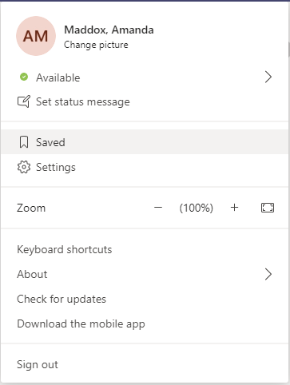
If that happens, re-click on your initials and select ‘Check for updates’.

Teams message bar will state message about checking for updates – This will disappear shortly.
Once complete a new message will state Teams needs to be refreshed. Click the link and Teams will close and re-open.
It should then be updated (the date shows the month, then the day). The number you see will vary as Teams updates every two weeks.

If you wish to check which version you are on go here and select ‘About’ then ‘Version’.

