3rd October 2023
Dear Parent/Carer,
RE: English, Maths and Science Revision Support Evening for families
We would like to invite you into the Academy for an evening presentation on strategies to support your child to revise English, Maths and Science.
The evening will run from 5:30pm to 7:00pm on Wednesday 1st November at school.
It will be divided into short presentations by each department with a time for questions at the end.
The aim is to give parents information on:
- - the best techniques to revise for each subject,
- - how to support your child with the revision process.

There will also be hints and tips to improve progress.

If you wish to attend, please can I ask you to register your interest on the google form:
https://forms.office.com/e/D4ije232Sf
If you are unable to access the form please return the attached slip to the office.
We look forward to working together to get the best possible outcomes for your child in their GCSEs in the summer.
Kind regards,
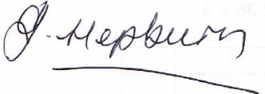
Jacqueline Hepburn
Assistant Principal.

Student name _____________________________ Tutor Group_____________
We will be attending the support evening on Wednesday 1st November:

Please state the number of members of your family attending

Parent Signature

