Wixams Academy
Student Feedback and Assessment
2023-24

Key Stage 3

Contact details

Mrs J Hepburn |  | jhepburn@wixamsacademy.co.uk

Contents

Letter of Introduction ………………………………..………………………………………. | 3
Formative Assessment ……………………………………………………………………….. | 4
Summative Assessment ……………………………………………………………………… | 5
KS3 Reports ………………………………………………………………………..……………… | 6
Estimated Target Grades ……………………………………………………………. | 7
Interpreting Target Estimates and attainment ……………………………. | 7
How to interpret KS3 Reports …………………………………………………….. | 8
Parent Consultations ………………………………………………………………………….. | 9

Letter of Introduction
Dear Parent/Carer,
At Wixams we fully embrace a 5 year curriculum which is broad and balanced whilst building the important foundations for Key Stage 4. We no longer see Key stage 3 (KS3 – Year 7-9) and Key stage 4 (KS4 – Year 10-11) as separate courses, but rather as a continuum. The curriculum has a greater focus on knowledge development, along with the opportunity to study the ‘big ideas’ of a subject in greater depth.

The new National Curriculum has changed from letters to numerical grades. As a result we use numbers to assess both KS3 and KS4. However, although the curriculum is a continuum, we have separate systems to assess KS3 and KS4.

- At KS3 we use a 5 number decimal system. A ‘W’ is placed in front of the attainment number to emphasise that this should not be compared to a GCSE grade.
- At KS4 we use the 1- 9 number scale that overlaps with the GCSE grades.

At Wixams, we have a feedback and assessment policy to allow us to more rigorously monitor and evaluate the impact of our curriculum on student knowledge and understanding. Details for each Key stage are given following this letter.

What we hope to achieve

A 5 year curriculum and assessment model which:

- Is focused on developing the key concepts, knowledge and skills needed for success in each subject.

- Is based on high expectations and challenge for all.

- Uses regular assessment and feedback which gives all students the chance to develop a secure understanding of the key ideas.

- Tracks against KS3 objectives to ensure mastery of this portion of the curriculum.

- Incorporates high quality end of term assessments, which help students develop the skills needed to tackle the subject.

These are ambitious aims, but we are committed to do all we can to prepare our students for the challenges that lie ahead.

Yours faithfully,
Jacqueline Hepburn,
Assistant Principal

This document discusses the KS3 Assessment structure. There is a parallel booklet for KS4 on the website in the Assessment tab or available on request from the office.

At Wixams, there is a combination of Formative assessment tasks and Summative Assessments.
Formative Assessment
Formative Assessment is an integral part of the learning process and as such, is present in lessons as an on-going and continuous process. Tasks may be short retrieval starters, low stakes quizzes or maybe an extended writing task for example.

At KS3 students are assessed against curriculum objectives. Following an extensive piece of work, there is detailed marking and feedback, and the student is expected to reflect and act upon that feedback during a dedicated time in lessons. We call this marking PIN, where the teacher identifies areas that are: worthy of Praise, areas that require Improvement and the Next steps to facilitate that improvement. This provides opportunities for students to develop further their knowledge, skills and understanding.
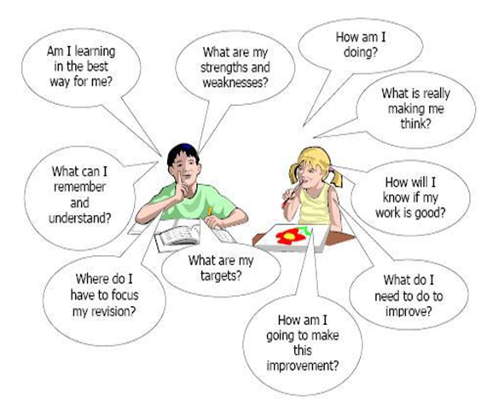

This type of assessment is not reported to parents and is used for student development. Parents can see feedback in student books but should be aware that some subjects such as English have a note book and an assessment book. If there are any queries about the feedback in student books these should be directed to the class teacher in the first instance.
Summative Assessment
Summative assessments take place towards the end of each term.

Summative assessments
- Provide a summary judgement about what has been learned by each student at a specific point in time

- Show what students can achieve without support
- Inform any subsequent intervention activities

Summative assessments take a variety of forms, depending on the nature of each subject.

For example, in Maths and Science they are most likely to be tests. In History and English extended writing may be prominent. While in Design and Technology, assessments may be based around design and make processes. In Dance and PE, teachers often rate the performance of students against set criteria.

Towards the end of the academic year there is also a test in all subjects. We pride ourselves on our tradition for all years to have summer tests in real exam conditions.

- In Year 7 to 9, subjects are tested in classes in a test week.
- In Year 10 and 11, subjects are tested in the Sports Hall.

We follow exam board procedures and where necessary students have special access arrangements for example, a reader or scribe.

We have found that this reduces anxiety as students approach Year 11 as they are clear of the expectations and systems.

KS3 Reports
Parents will receive 5 reports at Key stage 3:

Year 7  Spring Term February | - Estimated target grades for the end of year and student progress towards them.  - Information on attitudes to learning and homework.
Year 7 Summer Term July | - Estimated target grades for the end of year and a current grade*  - Information on attitudes to learning and  - Tutor pastoral comment giving more context and an overview of the year.
Year 8  Autumn Term December | - Estimated target grades for the end of year and student progress towards them.  - Information on attitudes to learning and homework.
Year 8 Summer Term – July: | - Estimated target grades for the end of year and a final grade for KS3.**  - Information on attitudes to learning and homework for the year.  - Tutor pastoral comment giving more context and an overview of the year

*In year 7, the current grade will be a Wixams number from 0-4 and will reflect student performance in summative tests with teacher assessment of progress in class.

**In Year 8, the final grade will be a Wixams number from 0-5 and will reflect student performance in summative tests with teacher assessment of progress in class.

Wixams numbers at KS3 are NOT the same as GCSE grades. The content at KS3 is different and the Wixams numbers relate directly to criteria and content from a KS3 progress map made by Wixams teachers for our curriculum.

Estimated Target Grades

We use Target grades to motivate students and to benchmark current performance against prior attainment. In this way students can challenge themselves without comparing to the performance of others. The word ‘estimated’ is particularly important as the way students learn and develop is notoriously difficult to measure.

Currently we use ambitious FFT* (Fischer Family Trust) estimates for performance at Year 11 and then give an end of Year estimation for expected performance for each year. As we now have external Year 11 results, we now use a curriculum attainment pathway based on the performance of our students on our own curriculum, to estimate end of year targets from Year 7-10. Teachers adjust these targets to ensure that they are aspirational for your child’s specific needs. (*FFT estimates are based on KS2 grades and compare the expected outcomes of thousands of students at GCSE. They are an estimate that schools use to set aspirational targets).

Interpreting Target Estimates and attainment

The following tables are only meant as a guide and are by their very nature estimates and approximations.

End of Year 7
Description of Current Progress | Wixams Estimated attainment grade | Primary KS2 SATs standardised scores
Emerging | W0.25-1.5 | 80-100
Expected | W1.75-2.75 | 100-110
Exceeding | W3-3.75 | 110-115
Excelling | W4 or better | 115+

The last column gives a guide to student prior attainment from primary school.

End of Year 8
Description of Current Progress | Wixams Estimated attainment grade
Emerging | W0.25-2.25
Expected | W2.5-3.5
Exceeding | W3.75-4.5
Excelling | W4.75 or better

How to interpret KS3 Reports

We regularly update our reports following parent feedback. As a result, we no longer report a golden target but instead list the progress through the year. At the end of the year, we also colour grades against the targets.
Please remember that KS3 attainment numbers reflect the KS3 curriculum content. They do not overlap with KS4 grades.

The target is specific to your child’s prior attainment.

Example 1:
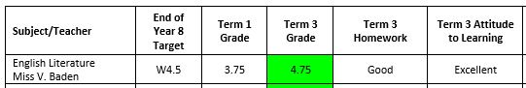
This student has exceeded their Target estimate and clearly works hard. The student should be proud of their achievements this year.

Example 2:
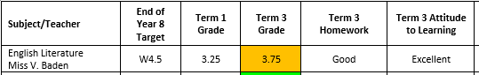
This student has not met their target estimate but has been working very hard. They are still exceeding in terms the curriculum. This is a high estimated target. The student should be proud of their achievements this year, but it is advised that the parent has a conversation with the subject teacher to determine whether this is a curriculum issue or whether the student needs to improve in particular areas.

Example 3:
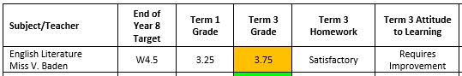
This student has not met their target estimate and is also not working hard with homework. Attitude to learning requires improvement so there are issues with this student’s focus and/or behaviour in lessons. Despite the high target the implication is that the student is under-achieving.
Example 4:
In addition, following parent feedback we will be adding an extra column at the end of the year for a teacher comment if it is not clear why the student has not met their target:
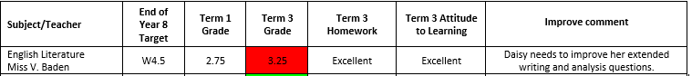

If there are any issues with interpreting your child’s report please contact the tutor or Mrs. Hepburn.

Parent Consultations
All parents will have the opportunity to meet with teachers at least once a year.

Year 7 have a progress review day with their child’s tutor in the autumn term.

Year 7 | Subject consultation with subject teachers in June.  This follows the completion of the course following the end of year tests.
Year 8 | Subject consultation with subject teachers in June.  This follows the completion of the course following the end of year tests.

Despite having these opportunities, we would encourage all parents to contact us immediately, throughout the year, if they wish to discuss their child’s progress.

We believe that it is through working together that we can help your child to reach their full potential.

