Wixams Academy
Student Feedback and Assessment
2023-24

Key Stage 4
Years 9, 10 and 11

Contact details

Mrs J Hepburn |  | jhepburn@wixamsacademy.co.uk

Contents
Letter of Introduction ………………………………..………………………………………. | 3
Formative Assessment ……………………………………………………………………….. | 4
Summative Assessment ……………………………………………………………………… | 5
KS3 Reports ………………………………………………………………………..……………… | 6
Estimated Target Grades ……………………………………………………………. | 7
Interpreting Target Estimates and attainment ……………………………. | 7
How to interpret KS4 Reports …………………………………………………….. | 8
Interpreting the 1-9 GCSE scale | 9
Parent Consultations ………………………………………………………………………….. | 10

Letter of Introduction
Dear Parent/Carer,
At Wixams we fully embrace a 5 year curriculum which is broad and balanced whilst building the important foundations for Key Stage 4. We no longer see Key stage 3 and Key stage 4 (KS4 – Years 9, 10 and 11) as separate courses, but rather as a continuum. The curriculum has a greater focus on knowledge development, along with the opportunity to study the ‘big ideas’ of a subject in greater depth.

The new National Curriculum has changed from letters to numerical grades. As a result we use numbers to assess both KS3 and KS4. However, although the curriculum is a continuum, we have separate systems to assess KS3 and KS4.

- At KS3 we use a 5 number decimal system. A ‘W’ is placed in front of the attainment number to emphasise that this should not be compared to a GCSE grade.
- At KS4 we use the 1- 9 number scale that overlaps with the GCSE grades.

At Wixams, we have a feedback and assessment policy to allow us to more rigorously monitor and evaluate the impact of our curriculum on student knowledge and understanding. Details for each Key stage are given following this letter.

What we hope to achieve

A 5 year curriculum and assessment model which:

- Is focused on developing the key concepts, knowledge and skills needed for success in each subject.

- Is based on high expectations and challenge for all.

- Uses regular assessment and feedback which gives all students the chance to develop a secure understanding of the key ideas.

- Tracks against KS3 objectives to ensure mastery of this portion of the curriculum.

- Incorporates high quality end of term assessments, which help students develop the skills needed to tackle the subject.

These are ambitious aims, but we are committed to do all we can to prepare our students for the challenges that lie ahead.

Yours faithfully,
Jacqueline Hepburn,
Assistant Principal

This document discusses the KS4 Assessment structure. There is a parallel booklet for KS3 on the website in the Assessment tab or available on request from the office.

At Wixams, there is a combination of Formative assessment tasks and Summative Assessments.
Formative Assessment
Formative Assessment is an integral part of the learning process and as such, is present in lessons as an on-going and continuous process. Tasks may be short retrieval starters, low stakes quizzes or maybe an extended writing task for example.

Following an extensive piece of work, there is detailed marking and feedback, and the student is expected to reflect and act upon that feedback during a dedicated time in lessons. We call this marking PIN, where the teacher identifies areas that are: worthy of Praise, areas that require Improvement and the Next steps to facilitate that improvement. This provides opportunities for students to develop further their knowledge, skills and understanding.

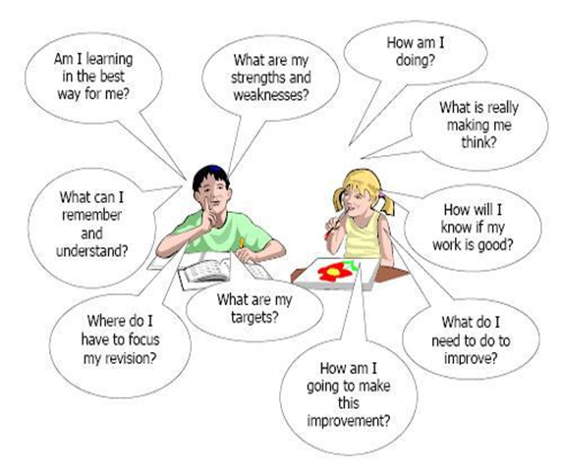

This type of assessment is not reported to parents and is used for student development. Parents can see feedback in student books but should be aware that some subjects such as English have a note book and an assessment book. If there are any queries about the feedback in student books these should be directed to the class teacher in the first instance.

Summative Assessment

Summative assessments take place towards the end of each term.

Summative assessments
- Provide a summary judgement about what has been learned by each student at a specific point in time

- Show what students can achieve without support
- Inform any subsequent intervention activities

Summative assessments take a variety of forms, depending on the nature of each subject.

For example, in Maths and Science they are most likely to be tests. In History and English extended writing may be prominent. While in Design and Technology, assessments may be based around design and make processes. In Dance and PE, teachers often rate the performance of students against set criteria.

Towards the end of the academic year there is also a test in all subjects. We pride ourselves on our tradition for all years to have summer tests in real exam conditions.

- In Year 7 to 9, subjects are tested in classes in a test week.
- In Year 10 and 11, subjects are tested in the Sports Hall.

We follow exam board procedures and where necessary students have special access arrangements for example, a reader or scribe.

We have found that this reduces anxiety as students approach Year 11 as they are clear of the expectations and systems.

KS4 Reports

Parents will receive 7 reports at Key stage 4:
Year 9  Autumn Term December | - Estimated target grades for the end of year.  - Current grade for English, Maths and Science.  - Student progress towards target for option subjects.  - Information on attitudes to learning and homework.
Year 9  Summer Term  July | - Estimated target grades for the end of year and a current grade*.  - Information on attitudes to learning and homework.  - Tutor pastoral comment giving more context and an overview of the year.
Year 10  Autumn Term December | - Estimated target grades for the end of year and a current grade*.  - Information on attitudes to learning and homework.
Year 10  Spring Term March/April | - Estimated target grades for the end of year and a current grade*.  - Information on attitudes to learning and homework.
Year 10  Summer Term  July | - Estimated target grades for the end of year, a current grade* and a predicted grade for the end of KS4.  - Information on attitudes to learning and homework.  - Tutor pastoral comment giving more context and an overview of the year.
Year 11  Mocks  January | - Estimated target grades for the end of year, a current grade based on the Mock grade and teacher assessment, and a predicted grade for the end of KS4.  - Information on attitudes to learning and homework.  - The student will have also received a Mocks result sheet prior to this report giving actual performance in these tests.
Year 11  Final report March/April | - Estimated target grades for the end of year, a current grade and a predicted grade for the end of KS4.  - Information on attitudes to learning and homework.  - There will also be a tutor pastoral comment giving more context and an overview of the year.
* The current grade will be a GCSE 1-9 grade and will reflect student performance in summative tests with teacher assessment of progress in class.

Estimated Target Grades

We use Target grades in the same way as KS3 to motivate students and to benchmark current performance against prior attainment. In this way students can challenge themselves without comparing to the performance of others. The word ‘estimated’ is particularly important as the way students learn and develop is notoriously difficult to measure – in fact it is almost akin to predicting the weather!

Currently we use ambitious FFT* (Fischer Family Trust) estimates for performance at Year 11 and then give an end of Year estimation for expected performance for each year. As we now have external Year 11 results, we now use a curriculum attainment pathway based on the performance of our students on our own curriculum, to estimate end of year targets from Year 7-10. Teachers adjust these targets to ensure that they are aspirational for your child’s specific needs. (*FFT estimates are based on KS2 grades and compare the expected outcomes of thousands of students at GCSE. They are an estimate that schools use to set aspirational targets).

Interpreting Target Estimates and attainment

In order to further emphasise the difference between KS3 and 4 we have now moved away from a decimal system to report KS4 grades and use a +,-,= sign to show how secure a student is at a particular grade

For example using a grade 5

New Wixams report | Description | Old Wixams report
5 or 5- | Student is not secure at this grade and could slip back to a Grade 4. May need more support. | 5 or 5.25
5= | Student is secure at this grade | 5.5
5+ | Student is secure and almost at the next grade | 5.75

Predicted grades will just be a pure grade without a sign.

In 2023, the average National Attainment 8 score was 4.62 (roughly speaking, the average grade for the best eight subjects). So by the end of Year 11 students are expected to gain a Grade 4 or 5.

The following table is meant as a guide and is just an approximation of nationally expected progress from Year 9 to 11.

Description of Current Progress | Year 11 | End of Year 10  Rough  Estimate of attainment | End of Year 9  Rough  Estimate of attainment
Standard Pass | 4- to 4+ | 3= to 3+ | 2+ to 3 -
Nationally Expected Attainment | 4= | 3+ | 3-
Above Average Pass | 5- to 5+ | 4- to 4+ | 3= to 3+
How to interpret KS4 Reports
We regularly update our reports following parent feedback. As a result, we no longer report a golden target but instead list the progress through the year. At the end of the year, we also colour grades against the targets.
It is not unusual for a student who gains a grade W3.75 (say) at the end of KS3 to be given a 2+ (say) at the beginning of KS4. This is because the content and skills are more extensive at KS4 and although the curriculums overlap there is not necessarily an assessment overlap with the reported attainment numbers.

Example 1:
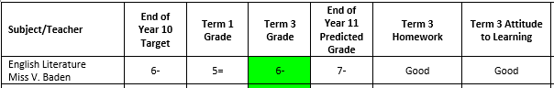
This student has reached their Target estimate and clearly works hard. The student should be proud of their achievements this year.

Example 2: 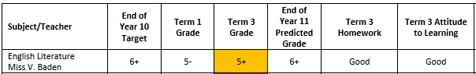
This student has not met their target estimate but has been working hard. They on track to meet Grade 6 by the end of Year 11, however their target grade for Year 11 is likely to increase. The student should be proud of their achievements this year, but it is advised that the parent has a conversation with the subject teacher to determine whether this is a curriculum issue or whether the student needs to improve in particular areas.

Example 3:
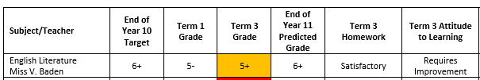
This student has not met their target estimate and is also not working hard with homework. Attitude to learning requires improvement so there are issues with this student’s focus and/or behaviour in lessons. The implication is that the student is under-achieving and may not reach their Year 11 target estimate which is likely to be higher.
Example 4:
In addition, following parent feedback we will be adding an extra column at the end of the year for a teacher comment if it is not clear why the student has not met their target:
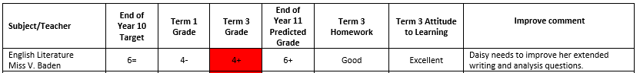

If there are any issues with interpreting your child’s report please contact the tutor or Mrs. Hepburn. At the end of the year a new video will be available.

How to interpret BTEC and OCR CNational grades

Grade | Code | Points
Level 2 Distinction * | L2D* | 8.5
Level 2 Distinction | L2D | 7
Level 2 Merit | L2M | 5.5
Level 2 Pass | L2P | 4
Level 1 Distinction | L1D | 3
Level 1 Merit | L1M | 2
Level 1 Pass | L1P | 1.25

Interpreting the 1-9 GCSE scale

The new GCSEs are more demanding and require higher levels of literacy and numeracy to access the top grades:

- the grading scale uses the numbers 1 to 9 to identify levels of performance, with 9 being the top grade

- the structure is such that all assessment happen at the end of the course and content is not divided into modules

- exams are the default method of assessment, except where they cannot provide valid assessment of the skills required

For those parents more used to the A* to G grading an approximate conversion
is given in the following graphic:

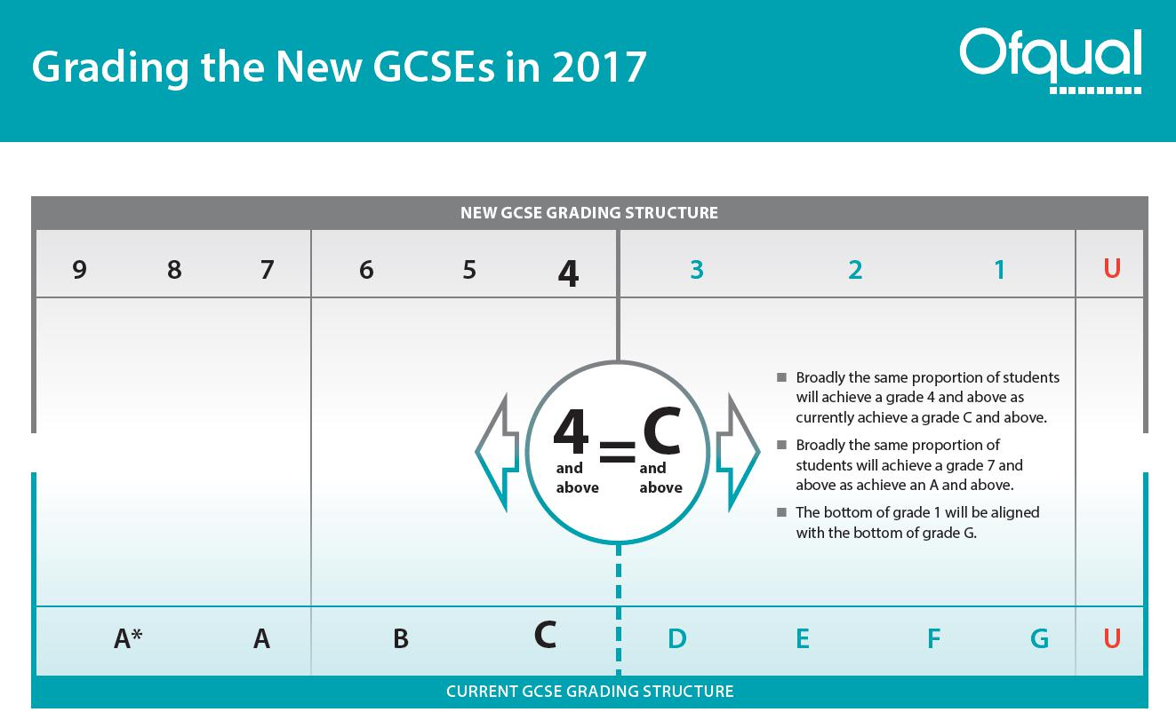

You can see that there are more grades at the top end and fewer grades at the lower end.

Grade 4 is described as a standard pass. This is roughly equivalent to a low to mid grade C.

Grade 5 is described as a good pass. It is roughly equivalent to a high C/low B.

Usually only around 5% of the entries gain a Grade 9 and this was not identified separately in the old system
Parent Consultations

All parents will have the opportunity to meet with teachers at least once a year.

Year 7 have a progress review day with their child’s tutor in the autumn term.

Year 9 | Subject consultation with subject teachers in December.  This is because this is the first year of their new course so we want to ensure that they have settled in and are supported.
Year 10 | Subject consultation with subject teachers in the March/April.  This helps support preparation for the summer tests.
Year 11 | Subject consultations in the first half of the Autumn term to prepare for the Mocks.  Some parents will be invited to speak to subject teachers or the HOY if there is an issue with progress in January following the Mocks.

Despite having these opportunities we would encourage all parents to contact us immediately, throughout the year, if they wish to discuss their child’s progress.

We believe that it is through working together that we can help your child to reach their full potential.

