Welcome
Welcome to the Politics A Level course at Wixams Academy! This bridging booklet will prepare you for the start of your course in September. It’s an incredibly fruitful and enriching course that will open many doors for your future. It is possibly the most adaptive and ever-changing A-level course on offer, as the turbulent political scene can change within a matter of days. Whilst the world develops around us, we must develop with it.
Studying A Level politics will develop your knowledge and understanding of how decisions are made in Britain; the ever-evolving political environment of the UK; British and global political structures and their historical contexts; political ideas, ideologies and their interrelationships; various political institutions and processes both national and global; various political actors and groups in affecting change; and much more. You will craft your ability in essay writing, critical thinking, analysis, evaluation, and judgement making. Ultimately, you will develop an understanding of the local, national, international, and global dimensions of politics.
Students who study A Level Politics are generally new to the subject, but do not let this deter you. Having a background in GCSE History or Citizenship may benefit, but it is not essential. We will start from ground zero. There is not an expectation to have any prior knowledge, but the purpose of this bridging work is to ease the impact of ‘hitting the ground running’. Right now, all you need is an open mind, passion, interest, desire, dedication to learn about the incredibly interesting subject of Politics.
A Level Politics is an attractive, academic, and employable qualification. It is highly regarded by universities, including Russell Group, as well as employers of all types. It is particularly relevant for legal and journalistic careers, public services, the civil service, and research. Besides being employable, this course will broaden and deepen your understanding of arguably what makes the world function and malfunction.

What will you study?
- British politics
- British government
- Ideologies: Conservatism, Socialism, Liberalism, Nationalism/Feminism
- Global politics
Some questions you may encounter in A level politics:
- To what extent is the UK a two-party state/political system?
- What is more radical: neoliberalism or socialism?
- What are the implications of China as a global power to US hegemony?
- In what ways was leaving the EU a positive thing?

What skills will you develop?
This is an academic and essay-based course. You will be formally assessed by your essay writing, however there will be bountiful opportunities for discussions and debates. A key skill you will learn is how to construct a supported argument and critique opposing arguments.
Alongside the written skills, you will develop your research skills, how to find relevant, topical and up-to-date evidence how to construct this persuasively.
You will develop evaluation skills in order to weigh up the strengths and weaknesses of opinions, statements and arguments.
You will learn how to draw links between various events, processes, ideas, ideologies and so on. You can find their contradictions, their similarities and so on.
Most importantly, you will learn how to think and write critically; how to question and argue effectively; how to make judgements and weigh up various elements of an argument; how to reach a logical, supports and justified conclusion.

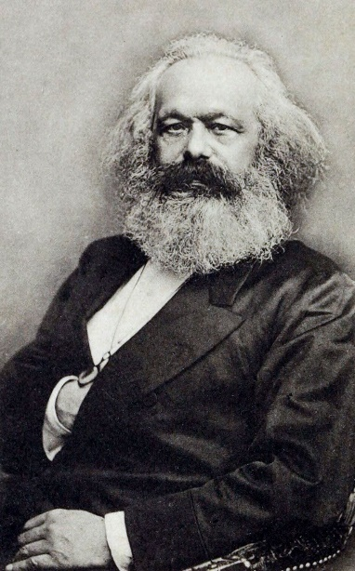
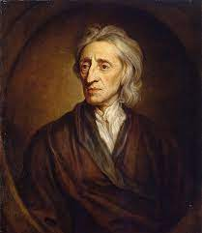
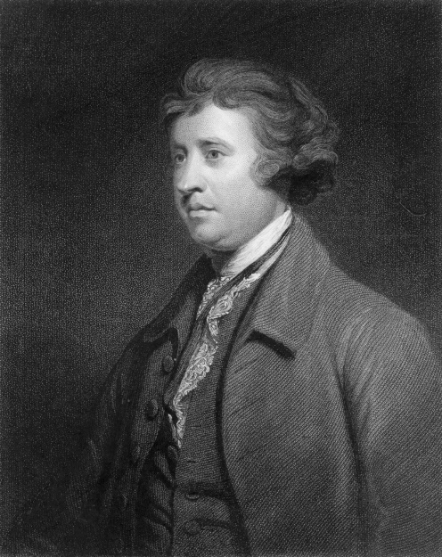
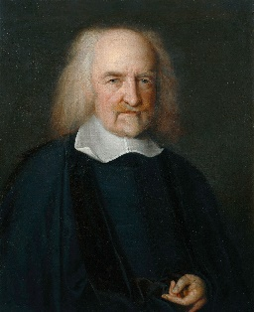
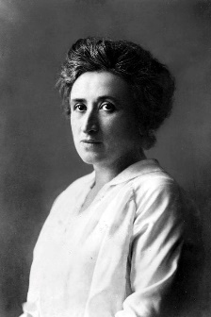
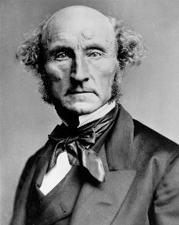
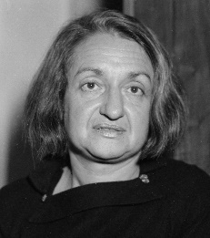

Assessment
You will sit three papers at the end of Year 13. The questions are essay based. We are using the Edexcel exam board.
UK Politics (33.3%) | UK Government (33.3%) | Comparative Politics (33.3%)
Section A: Political Participation | Section A: UK Government | B: Global Politics
- Democracy and participation  - Political parties  - Electoral systems  - Voting behaviour and the media | - The constitution  - Parliament  - Prime minister and executive  - Relations between the branches | - Sovereignty and globalisation  - Global governance  - Human and  environmental rights  - Power and developments  - Regionalism and the EU  - Comparative theories
Section B: Core Political Ideas | Section B: Non-Core Political Ideas
- Liberalism  - Conservatism  - Socialism | - Nationalism  - Feminism

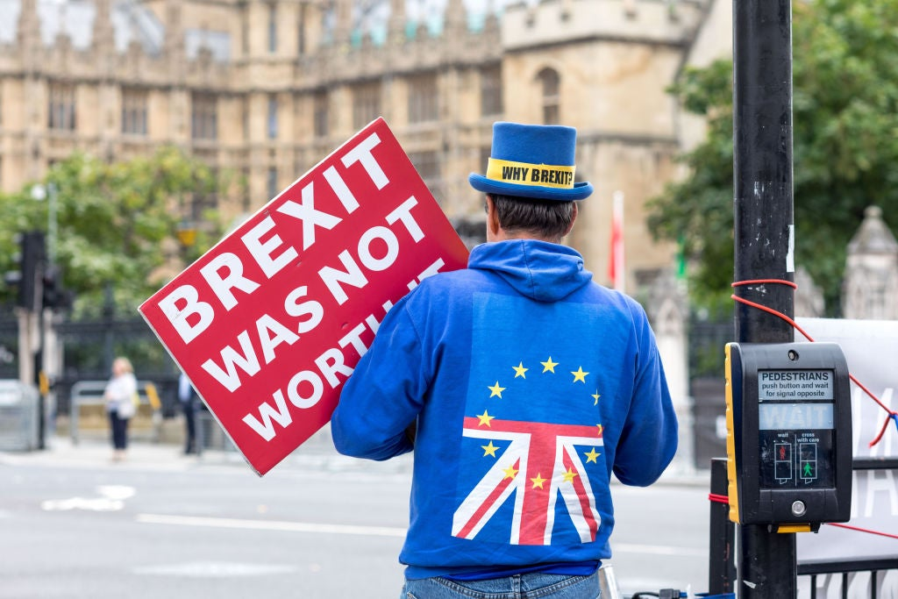
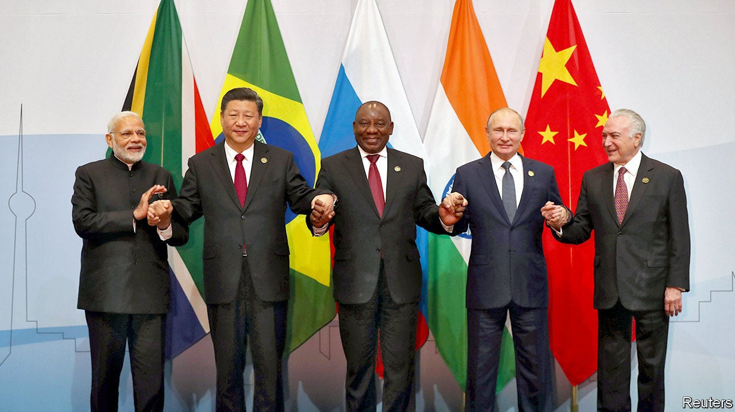
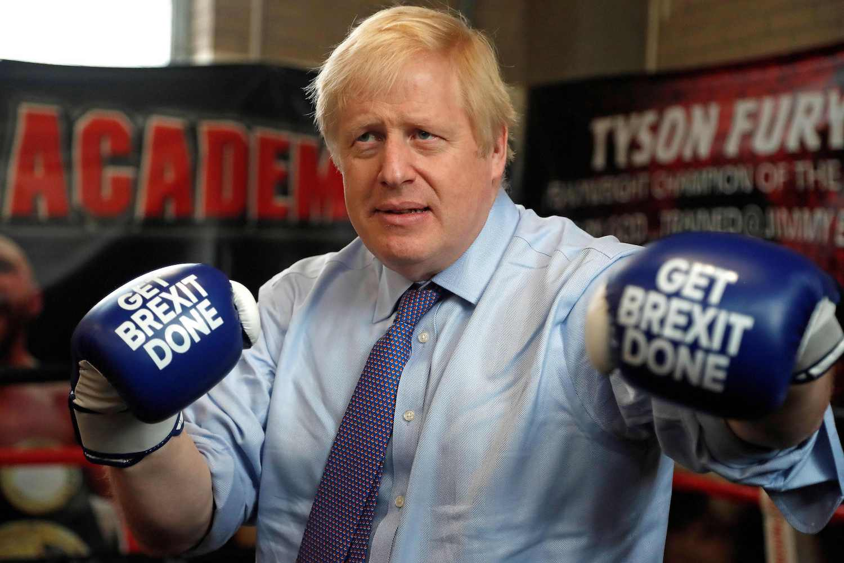

Getting Started

Key words task
There are numerous key terms in Politics. Please find out the definitions of each of the following words and explain their relevance to the course.

Direct democracy | Parliamentary sovereignty
Representative democracy | Common law
Coalition | Parliamentary privilege
Constitution | State
Hierarchy | Government
Laissez-faire | Direct action
Common ownership | Solidarity
Revisionism | Mutual aid
Devolution | Consumerism
Judiciary | Individualism
Lobbying | Discrimination
Suffrage | Identity politics

Source comprehension
In the final exams you will be asked to analyse small sources of political information.
Former Prime Minister David Cameron once said that the very thought of it made him feel ‘physically ill’. No, he wasn’t speaking about acts of terrorism or murder. He was referring to giving British prisoners the right to vote in UK elections. So, what are the issues? At present, there are just over 85,000 adults locked up in English and Welsh jails. Of these, an estimated 12,000 or so are foreign nationals who wouldn’t have the right to vote in UK parliamentary elections anyway. So that leaves around 73,000 inmates who would be eligible to cast their votes today, assuming that they weren’t behind bars. According to the current law – the Representation of the People Act (1983) – convicted prisoners are barred from voting in any elections.
Traditionally, convicted prisoners in the UK lost a wide range of legal and civic rights enjoyed by the rest of the adult population. In effect, they were reduced to a child-like status, and that included the loss of any voting rights. Most British politicians, from all parties, have vigorously defended the voting ban, despite legal challenges. Back in 2001, a prisoner named John Hirst took the government to the High Court in a bid to change the law. He lost. However, he then took his case to the European Court of Human Rights (ECtHR) in Strasbourg where, in 2005, he won. Despite Hirst’s victory in Europe, and a government promise to change the law, MPs supported a motion rejecting prisoner votes in Parliament in 2011. The voting figures say it all: 234 in favour and just 22 against.
So despite repeated rulings by the ECtHR, convicted prisoners are still barred from voting. There are various anomalies in the way the law works. For example, if a person is given a prison sentence that is then suspended, they are allowed to vote. Moreover, if a prisoner is automatically released on licence, as most are at the halfway point of their sentence, then they regain the right to participate in elections. Therefore, the argument that convicted criminals lose the vote isn’t as clear cut as it initially seems. Some have suggested compromises, such as permitting prisoners serving short sentences for minor offences to have a postal ballot. Others, including most MPs, remain adamantly opposed. The argument for permitting convicts to have postal ballots is that the right to participate in the democratic process might encourage some prisoners to take their civic responsibilities more seriously, or at least become more interested in politics.
Some European countries, including Austria, Bulgaria, Hungary and Russia, have similar laws to Britain and ban voting by convicted prisoners. Others, such as Belgium, France and Germany, ban voting by inmates convicted of certain serious crimes, such as treason or terrorism. At the other extreme, there are countries, including the Czech Republic, Denmark, Finland, Ireland, Spain, Sweden and Switzerland, that allow serving convicts to vote.
Source: http://metro.co.uk/2017/06/08/votes-for-prisoners-the-rights-and-rules-for-convicts-explained-6686982

Task 1: Define the following political and non-political items in the source
A | Inmates
B | Eligible
C | Convicted
D | Barred
E | Legal and civic rights
F | Vigorously
G | High Court
H | European Court of Human Rights
I | Motion
J | Postal ballot
K | Adamantly
L | Civic responsibilities
M | Treason
N | Serving convicts

Task 2: Using 2 differently coloured highlighters, indicate arguments in the source that:
- Support the view that the total ban on convicted prisoners voting should remain
- Support the view that some or all prisoners should be given the right to vote
Task 3: Select 2 arguments from each side and add them to the balanced see-saw below.

Building skills
Task: write a report (400 minimum, up to 1000 words) to answer the following question:
“To what extent was Corbyn’s Labour Party a return to the cause of Socialism?”
Below is one paper and two videos but you must find additional material to support your argument.
https://link.springer.com/content/pdf/bbm%3A978-3-030-34998-1%2F1.pdf (although it says 43 pages, it is not. It is 10 pages worth of reading).
https://www.youtube.com/watch?v=5b8_rp1GY7k&ab_channel=Channel4News https://www.youtube.com/watch?v=Uhhd86qd8JI&ab_channel=AlJazeeraEnglish

Aiming for success
Staying up to date on current affairs is paramount to success in A level Politics. You must be able to analyse political information, research issues and stay informed. It’s important to get in the habit of following current affairs. If you start these habits, they will become second nature once the course begins.

Magazines both online and paper
The Spectator
Private Eye
New Statesmen
The Economist
Tribune

Newspapers
The Guardian
The Daily Telegraph
The Financial Times
Morning Star

Television
The News: Channel 4 News, BBC News, Good Morning Britain, The One Show,
Other Political shows: Have I Got News For You, Newsnight, Question Time, Peston, The Andrew Marr Show
News Channels: Sky News, BBC News, Al Jazeera, Euronews, GB News

YouTube
There are so many YouTube videos that can be beneficial for your understanding of Politics. At the same time, there are numerous that may make unsubstantiated propositions and arguments, oftentimes not backed up by evidence. As your skills develop, you will be able to critically analyse these forms of media.

Twitter
Twitter can be one of the most powerful tools in staying informed. Most news sources have accounts, as well as various non-official accounts spreading information around the world. Be careful – some tweets can be unsubstantiated, make sure you fact-check and cross reference! Similarly, users are free to twist information to suit their ideology of agenda.
Again, this is a skill that you will nurture throughout the course.

Current affairs task
In this task you have the freedom to choose the topic. What interests you? Make a presentable resource (PowerPoint, poster) on a particular issue, national or global, that interests you. Maybe it affects you?
Possible ideas to give you inspiration:
- Rise of patriarchal extremism
- Repeal of roe vs wade
- UK Home Office’s Rwanda scheme
- Criminalisation of protests
- War in Ukraine
- Rise of neo-fascism across the globe
- Police brutality

UK politics task
Complete the task in bold below, and then one from the list. Please complete on paper and bring to class in September.
Task 1: Make a list of the reasons why the UK is considered democratic and undemocratic.
Task 2: Choose one of the below tasks:

- Go to the UK Supreme Court website https://www.supremecourt.uk/ and look at the profiles of the judges. Choose 5 and create Top Trump cards with your own subheadings.
- Read a ‘broadsheet’ newspaper such as the Times or the Guardian. Identify at least one article of interest in UK politics today. Write a rebuttal to the piece in no more than 250 words.
- Visit either the Conservative or Labour Party websites and out 5 of their key aims. Write a critique of each of these 5 aims.
- Create a two-page statistical report on the results of the 2019 General Election.
- Create a visual storyboard showing how the First Past The Post (FPTP) electoral system works
- Write an email to your MP about a current affairs issue that is important to you. Bring in a copy of your letter and any reply you get, annotated with your responses
(remember you will need to include your name and address to get a response!)

Extension tasks

Reading list
Below are some suggested readings, you may read around them. Politics has a broad literature; the important thing is to start somewhere. Reading is a powerful tool and gift.
The Politics Book: Big Ideas, Simply Explained by DK
Politics for Beginners by Usborne
British Politics by Richard Grayson
Making a Success of Brexit by Roger Bootle
Political Ideologies by Andrew Heywood
The New Poverty by Stephen Armstrong
The Ways of the World by David Harvey
Seventeen Contradictions and the Crises of Capitalism by David Harvey
Prisoners of Geography by Tim Marshall
A Very Short Introduction series: there are thousands of titles, feel free to ready any that are relevant to the course ie liberalism, socialism, conservatism, globalisation, Brexit, British Politics, the British constitution…

Ideology task
Complete this ideology test at https://8values.github.io/
Draw your results on a piece of paper and do a small research activity on the characteristics of your ideology. Make a list of the issues you may have with it. Self-criticism is important!

TV, film, and documentaries.
There are several political TV shows and documentaries you can watch that can supplement your learning, or simply make for enjoyable watching. For instance, Yes Minister, The Thick of It, The Crown. VICE make several documentaries that may interest you. Brexit: The Film. V for Vendetta. If you want any documentaries, feel free to email me. There are many that can help on the topic of globalisation, such as Poverty Inc., The Shock Doctrine. BBC have several documentaries in the category ‘The Battle for Power’ which is directly relevant to the course.

