A Level Media Studies
Bridging Tasks

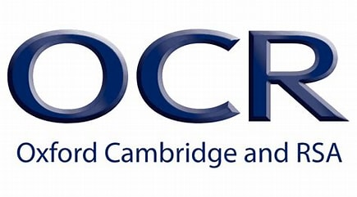

The media play a central role in contemporary culture, society and politics. They shape our perceptions of the world through the representations, ideas and points of view they offer. The media have real relevance and importance in our lives today, providing us with ways to communicate, with forms of cultural expression and the ability to participate in key aspects of society. The economic importance of the media is also unquestionable. The media industries employ large numbers of people worldwide and generate significant global profit. The globalised nature of the contemporary media, ongoing technological developments and more opportunities to interact with the media suggest their centrality in contemporary life can only increase.

Please complete the following tasks:

Task 1 - Research ALL of the critics listed below: Make notes on these and be prepared to discuss their theoretical approaches to Media, with reference to specific textual examples
Media Language
• Semiotics, including Roland Barthes
• Narratology, including Tzvetan Todorov
• Structuralism, including Claude Lévi-Strauss
Representation
• Theories of representation, including Stuart Hall
• Theories of gender performativity, including Judith Butler
• Theories around ethnicity and postcolonial theory, including Paul Gilroy
Media Industries
• Power and media industries, including Curran and Seaton
• Regulation, including Livingstone and Lunt
• Cultural industries, including David Hesmondhalgh
Audiences
• Media effects, including Albert Bandura
• Cultivation theory, including George Gerbner
• Reception theory, including Stuart Hall

Task 2 – Compare the choices that have been made in the representation of ethnicity or gender in a film poster (of your choice) and a music video (of your choice).
In your answer, you must consider:
• How ethnicity/gender is represented through processes of selection and combination
• Reasons for the choices made in the representation of ethnicity/gender
• The similarities and differences in the representations of ethnicity/gender
• How far the representations relate to relevant media contexts
(750 words)

Task 3 – Watch some clips from TED Talks about media representation- and make notes
David Puttnam: Does the media have a "duty of care"? | TED Talk

Task 4: - Look at some news articles from the general election (the results) and discuss how the winning/loosing parties have been represented.
Look at The Daily Mail and The Guardian websites. Have they represented the winning party positively or negatively? Why do you think this might be? (screen shot some articles that discuss this to add to your work).

Please bring this piece of work with you to your first Media Lesson in September.
Have a lovely a summer

