**Maths and Further Maths Bridging Work**

**Name: ……………………………………………………….**

### Welcome to A Level Mathematics!

We’re really glad you’ve chosen to study one of the most valuable A Level courses. It will open up opportunities for you and take you into a fascinating and important world.

But the truth is that this is going to be tough, and many students struggle or even fail very early on.

* Passing your GCSEs does not mean you will succeed.
* Even getting a grade 7+ does not mean you will succeed
* Buying revision guides and a fancy calculator does not mean you will succeed.

None of this helps if you cannot work confidently with algebra – solving equations and expanding brackets in your sleep.

This bridging booklet will enable you to consolidate your mathematical skills ready for A-Level mathematics and A-Level further mathematics.

The work in the following pages is not designed to teach new skills but rather to hone your existing ones. Hopefully, these skills are not new to you but we recognise that, due to various factors, you may not be 100% confident in them. As with good GCSE work, A-Level expects a full explanation of working, showing all steps of calculation so please don’t look for shortcuts whilst working through this booklet. Show all steps of calculation neatly: ask yourself, ‘Would you be proud of this work going on the wall?’

I’ll say again, one of the main foci of this bridging work is algebra; being able to manipulate and work with algebra fluently will give you a distinct advantage at A-Level. When you find ‘gaps’ in your knowledge you should take the opportunity to independently practise BEFORE the course begins – September is already too late.

There are many excellent websites (YouTube videos are extremely helpful) where you can find the required practise ([www.corbettmaths.com](http://www.corbettmaths.com/), <https://www.drfrostmaths.com/>). On a final note, just because you can multiply out brackets, it doesn’t mean that you should. Indeed, at this level it is often better to keep an expression in its factorised (bracketed) form.

You must bring this work with you: complete, marked and corrected. There will be a assessment on these topics in the first few weeks of your course; it is expected that all A Level Mathematics students will demonstrate an excellent understanding of all topics in these assessment.

Good luck

|  |  |  |
| --- | --- | --- |
| **Topic** | **Done Exercise (✓ )** | **☺ / 😐 / ☹** |
| **1 -** Simple algebraic expressions |  |  |
| **2 -** Algebraic fractions |  |  |
| **3 -** Quadratic expressions |  |  |
| **4 –** Cancelling |  |  |
| **5 –** Simultaneous equations |  |  |
| **6 -** Fractional and negative powers, and surds |  |  |
| **7 –** Linear inequalities |  |  |
| **8 –** Straight line graphs |  |  |
| **9 -** Trigonometry |  |  |

# Algebra

Many people dislike algebra; for many it is the point at which they start switching off mathematics. But do persevere – most of it is natural enough when you think about it the right way.

### 1 Simple algebraic expressions



Some very basic things here, but they should prove helpful.

Are you fully aware that  and  are the same thing?

***Example 1*** Find the value of *a* for which  is always true.

***Solution*** Dividing 8 by 11 and multiplying by (5*x* – 4) is the same as multiplying 8 by (5*x* – 4) and dividing by 11. So *a* = 11.



*You do not need to multiply anything out to see this!*

Remember that in algebraic fractions such as , the line has the same effect as a bracket round the denominator. You may well find it helpful actually to *write in* the bracket: .

***Example 2***Solve the equation 

***Solution*** Multiply both sides by (*x* – 2): 3 = 12(*x* – 2)

Multiply out the bracket: 3 = 12*x* – 24

Add 24 to both sides: 27 = 12*x*

Divide by 12: .

A common mistake is to start by dividing by 3. That would give  [*not* *x* – 2 = 4] and you will still have to multiply by (*x* – 2).

Don’t ever be afraid to get the *x*-term on the *right*, as in the last line but one of the working. After all, 27 = 12*x* means just the same as 12*x* = 27

***Example 4*** Solve the equation 

***Solution*** Do ***not*** multiply out the brackets to get fractions – that leads to horrible numbers! Instead:

Multiply both sides by 15: 

Choose 15 as it gets rid of all the fractions.

Cancel down the fractions: 



*Now* multiply out: 18*x* + 27 = 28*x* – 63

90 = 10*x*

Hence the answer is *x* = 9

This makes the working very much easier. ***Please don’t*** respond by saying “well, my method gets the same answer”! You want to develop your flexibility and your ability to find the easiest method if you are to do well at A Level, as well as to be able to use similar techniques in algebra instead of numbers. It’s not just this example we are worried about – it’s more complicated examples of a similar type.

### 

### Exercise 1

**1** Find the values of the letters *p*, *q* and *r* that make the following pairs of expressions always equal.

(a)  (b)  (c) 

**2** Solve the following equations.

(a)  (b)  (c) 

**3** Make cos *C* the subject of the formula *c*2 = *a*2 + *b*2 – 2*ab* cos *C*.

**4** (a)Multiply  by 8. (b) Multiply (*x* + 2) ÷ 3 by 12.

(c) Multiply by 6. (d) Multiplyby 8.

**5** Solve the following equations.

(a)  (b) 

(c) 

**6** Make *x* the subject of the following equations.

(a)  (b) 

**7** Simplify the following as far as possible.

(a)  (b) 

(c)  (d) 

### 2 Algebraic Fractions

Many people have only a hazy idea of fractions. That needs improving if you want to go a long way with maths – you will need to be confident in handling fractions consisting of letters as well as numbers.

Remember, first, how to multiply a fraction by an integer. You multiply only the top *[what happens if you multiply both the top and the bottom of a fraction by the same thing?]*

***Example 1*** Multiply  by 2.

***Solution*** 3× 2 = 6*x*, so the answer is . (*Not* !)

***Example 2*** Divide  by *y*.

***Solution*** , so the answer is . [Don’t forget to simplify.]

***Double fractions, or mixtures of fractions and decimals, are always wrong.***

For instance, if you want to divide  by 2, you should not say  but . This sort of thing is extremely important when it comes to rearranging formulae.

***Example 3*** Make *r* the subject of the equation *V* = π*r*2*h*.

Don’t “divide by ”.

***Solution*** Multiply by 2: 2*V* = π*r*2*h*

Divide by π and *h*:  = *r*2

Square root both sides: .

You should *not* write the answer as  or , as these are fractions of fractions.

Make sure, too, that you write the answer properly. If you write √2*V*/π*h* it’s not at all clear that the whole expression has to be square-rooted and you will lose marks.

You will often want to combine two algebraic expressions, one of which is an algebraic fraction, into a single expression. You will no doubt remember how to add or subtract fractions, using a common denominator.

***Example 4***Simplify.

***Solution***Use a common denominator. [You must treat (*x* – 1) and (*x* + 1) as separate expressions with no common factor.]



 .

Do use brackets, particularly on top – otherwise you are likely to forget the minus at the end of the numerator (in this example subtracting -1 gives +1).

Don’t multiply out the brackets on the bottom. You will need to see if there is a factor which cancels out (although there isn’t one in this case).

***Example 5*** Write  as a single fraction.

***Solution* **





This method often produces big simplifications when roots are involved

### Exercise 2



**1** Work out the following. Answers *may* be left as improper fractions.

(a)  (b)  (c)  (d) 

(e)  (f)  (g)  (h) 

(i)  (j)  (k)  (l) 

(m)  (n)  (o)  (p) 

**2** Make *x* the subject of the following formulae.

(a) *A* = π*x*2 (b)  (c) (*u* + *v*) = *tx* (d) 

**3** Write as single fractions.

(a)  (b)  (c) (d)  (e)  (f)  (g) 

**Further Maths Only**

**4\*** Write as single fractions.

(a)  (b)  (c) 

### 3 Quadratic Expressions

You will no doubt have done much on these for GCSE. But they are so prominent at A Level that it is essential to make sure that you are never going to fall into any traps.

First, a reminder that (a) (*x* + 3)2 is ***not*** equal to *x*2 + 9

(b)  is ***not*** equal to *x* + *y*.

If you always remember that “square” means “multiply by itself” you will remember that .

A related process is to write a quadratic expression such as  in the form . This is called ***completing the square***. Completing the square for quadratic expressions in which the coefficient of is 1 is very easy. The number *a* inside the brackets is always half of the coefficient of *x*.

***Example 1*** Write *x* 2 + 6*x* + 4 in the form (*x* + *a*)2 + *b*.

***Solution***  *x*2 + 6*x* + 4 = (*x* + 3)2 – 9 + 4

= (*x* + 3)2 – 5.

This version immediately gives us several useful pieces of information. For instance, we now know a lot about the graph of *y* = *x*2 + 6*x* + 4:

* It is a translation of the graph of *y* = *x*2 by 3 units to the left and 5 units down
* Its line of symmetry is *x* = –3
* Its lowest point or vertex is at (–3, –5)

And we can solve the equation *x*2 + 6*x* + 4 = 0 *exactly* without having to use the quadratic equation formula, to locate the roots of the function:

*x*2 + 6*x* + 4 = 0

⇒ (*x* + 3)2 – 5 = 0

⇒ (*x* + 3)2 = 5

⇒ *x* = –3 ± √5 [don’t forget that there are two possibilities!]

### Exercise 3

**1** Write without brackets.

(a) (*x* + 5)2 (b) (3*x* – 2)2 (c) (3*x* + 4)(3*x* – 4)

**2** Simplify the following equations into the form *ax* + *by* + *c* = 0.

(a) (*x* + 3)2 + (*y* + 4)2 = (*x* – 2)2 + (*y* – 1)2

(b) (2*x* + 1)2 + (*y* – 3)2 = (2*x* + 3)2 + (*y* + 1)2

**3** Simplify the following where possible.

(a)  (b)  (c) 

(d)  (e)  (f) 

**4** Write the following in the form (*x* + *a*)2 + *b*.

(a) *x*2 + 8*x* + 19 (b) *x*2 – 10*x* + 23 (c) *x*2 – 5*x* – 6

**5** Factorise as fully as possible.

(a) *x*2 – 25 (b) 4*x*2 – 36 (c) 4*x*2 – 9*y*4

(d) 3*x*2 – 7*x* + 2 (e) 3*x*2 – 5*x* + 2 (f) 6*x*2 – 5*x* – 6

**Further Maths Only**

**6\*** Multiply out and simplify.

(a)  (b)  (c) 

### 

### 4 Cancelling

The word “cancel” is a very dangerous one. It means two different things, one safe enough and the other very likely to lead you astray.

You can cancel *like terms* when they are added or subtracted.

***Example 1*** Simplify (*x*2 – 3*xy*) + (3*xy* – *y*2).

***Solution*** (*x*2 – 3*xy*) + (3*xy* – *y*2) = *x*2 – ~~3~~*~~xy~~* + ~~3~~*~~xy~~* – *y*2 = *x*2 – *y*2.

The “3*xy*” terms have “cancelled out”. This is safe enough.

It is also usual to talk about “cancelling down a fraction”. Thus  = . However, this tends to be very dangerous with anything other than the most straightforward numerical fractions. Consider, for instance, a fraction such as . If you try to “cancel” this, you’re almost certain not to get the right answer, which is in fact  (as we will see in Example 2, below).

***Example 2*** Simplify .

***Solution*** Factorise the top as *x*(*x* + 2*y*) and the bottom as *y*(*x* + 2*y*):



Now it is clear that both the top and the bottom have a factor of (*x* + 2*y*).

So this can be divided out to give the answer of .

*Don’t “cancel down”. Factorise if you can; divide all the top and all the bottom.*

Try instead to use the word “divide”. What happens when you “cancel down”  is that you *divide top and bottom* by 5. If you can divide both the top and bottom of a fraction by the same thing, this is a correct thing to do and you will get a simplified answer.

**Taking out factors**

I am sure you know that 7*x*2 + 12*x*3 can be factorised as *x*2(7 + 12*x*).

You should be prepared to factorise an expression such as 7(*x* + 2)2 + 12(*x* + 2)3 in the same way.

***Example 3***  Factorise 7(*x* + 2)2 + 12(*x* + 2)3

***Solution*** 7(*x* + 2)2 + 12(*x* + 2)3 = (*x* + 2)2(7 + 12(*x* + 2))

= (*x* + 2)2(12*x* + 31).

The only differences between this and 7*x*2 + 12*x*3 are that the common factor is (*x* + 2)2 and not *x*2; and that the other factor, here (7 + 12(*x* + 2)), can be simplified.

If you multiply out the brackets you will get a cubic and you will have great difficulty in factorising that. ***Don’t multiply out brackets if you can help it!***

### 

### Exercise 4

**1** Simplify the following as far as possible.

(a) 5*x* + 3*y* + 7*x* – 3*y* (b) 3*x*2 + 4*xy* + *y*2 + *x*2 – 4*xy* – *y*2.

(c)  (d)  (e) 

(f)  (g)  (h) 

(i)  (j)  (k) 

**2** Make *x* the subject of the following formulae.

(a)  (b) 

**3** Simplify the following.

(a)  (b) 

**4** Simplify into a single factorised expression.

(a) (*x* – 3)2 + 5(*x* – 3)3 (b) 4*x*(2*x* + 1)3 + 5(2*x* + 1)4

**(c)\***  **(d)**\* 

**5** Simplify as far as possible.

(a)  (b) 

 (c)  (d) 

**(e)\***  **(f)**\* 

### 5 Simultaneous equations

I am sure that you will be very familiar with the standard methods of solving simultaneous equations (elimination and substitution). You will need to be very familiar with both.

***Example 1***Solve the simultaneous equations 3*x* + *y* = 5 and *x* + *y* = 1

***Solution*** Subtract the second equation from the first equation to eliminate the y term.

3*x* + *y* = 5

*– x* + *y* = 1

2*x* = 4 So *x* = 2

To find the value of *y*, substitute *x*= 2 into one of the original equations.

Using *x* + *y* = 1

2 + *y* = 1 So *y* = −1

***Example 2***Solve 2*x* + 3*y* = 2 and 5*x* + 4*y* = 12 simultaneously.

***Solution*** Multiply the first equation by 4 and the second equation by 3.

(2*x* + 3*y* = 2) × 4  8*x* + 12*y* = 8

Then subtract the first equation from the second (5*x* + 4*y* = 12) × 3 15*x* + 12*y* = 36

7*x* = 28

So *x* = 4

Substitute x = 4 into one of the original equations. Using 2*x* + 3*y*  = 2

2 × 4 + 3*y* = 2 So *y* = −2

Remember, simultaneous equations are **both true** at the same time, so these values will work for both equations. This is a useful way to check your work.

***Example 3***Solve the simultaneous equations *y* = 2*x* + 1 and 5*x* + 3*y* = 14

***Solution*** Substitute 2x + 1 for y into the second equation.

5*x* + 3(2*x* + 1) = 14

Expand the brackets and simplify 5*x* + 6*x* + 3 = 14

Solve to find *x* 11*x* + 3 = 14

11*x* = 11 So *x* = 1

Substitute x = 1 into one of the original equations. Using *y* = 2*x* + 1

*y* = 2 × 1 + 1 So *y* = 3

### Exercise 5

Solve the following simultaneous equations.

**1** 4*x* + *y* = 8 **2** 3*x* + *y* = 7

*x* + *y* = 5 3*x* + 2*y* = 5

**3** 4*x* + *y* = 3 **4** 3*x* + 4*y* = 7

3*x* – *y* = 11 *x* – 4*y* = 5

**5** 2*x* + *y* = 11 **6** 2*x* + 3*y* = 11

*x* – 3*y* = 9 3*x* + 2*y* = 4

**7** *y* = *x* –4 **8** *y* = 2*x* – 3

2*x* + 5*y* = 43 5*x* – 3*y* = 11

**9** 2*y* = 4*x* + 5 **10** 2*x* = *y* – 2

9*x* + 5*y* = 22 8*x* – 5*y* = –11

**11** 3*x* + 4*y* = 8 **12** 3*y* = 4*x* – 7

2*x* – *y* = –13 2*y* = 3*x* – 4

**13** 3*x* = *y* – 1 **14** 3*x* + 2*y* + 1 = 0

2*y* – 2*x* = 3 4*y* = 8 – *x*

**15** Solve the simultaneous equations 3*x* + 5*y* − 20 = 0 and .

### 6 Fractional and negative powers, and surds

This may seem a rather difficult and even pointless topic when you meet it at GCSE, but you will soon see that it is extremely useful at A Level, and you need to be confident with it.

***Negative*** powers give ***reciprocals*** (1 over the power).

***Fractional*** powers give ***roots*** (such as 3√*x*).

***x*0 = 1** for any *x* (apart from 00 which is undefined).

***Examples 1*** (a) ** (b)  (c) *π* 0 = 1

(d) . The easiest way of seeing this is to write it as 

You will make most use of the rules of ***surds*** when checking your answers! An answer that you give as  will probably be given in the book as , and  as . Before worrying why you have got these wrong, you should check whether they are equivalent!

***Examples 2***

Indeed, they are, as



and

.

The first of these processes is usually signalled by the instruction “write in surd form” and the second by “rationalise the denominator”.

Remember also that to put a square root in surd form you take out the *biggest* square factor you can. Thus √48 = √16 × √3 = 4√3 (noting that you should take out √16 and not √4).

### 

### Exercise 6

**1** Write the following as powers of *x*.

(a)  (b)  (c)  (d)  (e)  (f) 

**2** Write the following without negative or fractional powers.

(a) *x*–4 (b) *x*0 (c) *x*1/6 (d) *x*3/4  (e) *x*–3/2

**3** Write the following in the form *axn*.

(a)  (b)  (c)  (d)  (e) 6

**4** Write as sums of powers of *x*.

(a)  (b)  (c) 

**5** Write the following in surd form.

(a)  (b)  (c)  (d)  (e) 

**6** Rationalise the denominators in the following expressions.

(a)  (b)  (c) 

(d)  (e) 



**7**\* Simplify 

### 7 Linear inequalities

All the methods you’ve developed for solving linear equations will be highly relevant for solving linear inequalities. Care needs to be taken though to understand and communicate the results.

***Example 1***Solve −8 ≤ 4x < 16

***Solution*** Divide all three terms by 4. −8 ≤ 4*x* < 16

−2 ≤ *x*  < 4

At this level you will also be required to deal with multiplication and division by negative numbers. This can be done, but has the additional effect of changing the direction of the inequality.

***Example 2***Solve 2 − 5*x* ≥ −8

***Solution***  2 − 5*x* ≥ −8

Subtract 2 from both sides.  −5*x* ≥ −10

Divide through by -5, remembering to reverse the inequality  *x* ≤ 2

### Exercise 7

**1** Solve these inequalities.

**a** 4*x* > 16 **b** 5*x* – 7 ≤ 3 **c** 1 ≥ 3*x* + 4

**d** 5 – 2*x* < 12 **e**  **f** 8 < 3 – 

**2** Solve these inequalities.

**a**  **b** 10 ≥ 2*x* + 3 **c** 7 – 3*x* > –5

**3** Solve

**a** 2 – 4*x* ≥ 18 **b** 3 ≤ 7*x* + 10 < 45 **c** 6 – 2*x* ≥ 4

**d** 4*x* + 17 < 2 – *x* **e** 4 – 5*x* < –3*x* **f** –4*x* ≥ 24

**4** Solve these inequalities.

**a** 3*t* + 1 < *t* + 6 **b** 2(3*n* – 1) ≥ *n* + 5

**5** Solve.

**a** 3(2 – *x*) > 2(4 – *x*) + 4 **b** 5(4 – *x*) > 3(5 – *x*) + 2



**6** Find the set of values of *x* for which 2*x* + 1 > 11 and 4*x* – 2 > 16 – 2*x*.

### 8 Straight line graphs

Graphs form an essential bridge between algebra and diagrams. Using them confidently and in a range of contexts is a massive help at this level.It all begins with a clear understanding of gradient, and how it relates to the y = mx + c equation. We then move on to being able then to work with points and equations in different formats.

***Example 1*** Find the equation of the line which passes through the point (5, 13) and has gradient 3.

*m* = 3

Substitute gradient into the equation *y* = *mx* + *c*. *y* = 3*x* + *c*

Substitute in the coordinates *x* = 5 and *y* = 13. 13 = 3 × 5 + *c*

13 = 15 + *c*

*c* = −2

Substitute *c* = −2 into the equation *y*= 3*x*+ *c y* = 3*x* − 2

***Example 2*** Find the gradient and the *y*-intercept of the line with the equation 3*y* − 2*x* + 4 = 0.

Make *y* the subject of the equation. 3*y* − 2*x* + 4 = 0

3*y* = 2*x* − 4

Divide through by three to get the form *y* = … 

The gradient is *m* and the *y*-intercept is *c*. Gradient = *m* = 

*y*-intercept = *c* = 

You will learn that drawing a diagram, *especially* when not instructed, is a really good idea, allowing you to get a much clearer idea of what you should be doing.

***Example 3*** Find the equation of the line passing through the points with coordinates (2, 4) and (8, 7).

2

8

4

7

x

x

Draw a quick sketch

Gradient = $\frac{change in y}{change in x}=\frac{3}{6}=\frac{1}{2}$

Substitute the gradient into the equation of a straight line *y*= *mx*+ *c*. 

Substitute the coordinates of either point into the equation. 

*c* = 3

Substitute *c* = 3 into the equation 

***Example 4*** Find the equation of the line perpendicular to *y* = 2*x* − 3 which passes through   
the point (−2, 5).

The gradient of the perpendicular line is . *m* = 2



Substitute *m* =  into *y* = *mx* + *c*. 

Substitute (–2, 5) into the equation  

*c* = 4

Substitute *c* = 4 into . 

### Exercise 8

**1** Find the gradient and the *y*-intercept of the following equations.

**a** *y* = 3*x* + 5 **b** *y* = *x* – 7

**Hint**

Rearrange the equations to the form *y* = *mx* + *c*

**c** 2*y* = 4*x* – 3 **d** *x* + *y* = 5

**e** 2*x* – 3*y* – 7 = 0 **f** 5*x* + *y* – 4 = 0

**2** Copy and complete the table, giving the equation of the line in the form *y* = *mx* + *c*.

|  |  |  |
| --- | --- | --- |
| **Gradient** | ***y*-intercept** | **Equation of the line** |
| 5 | 0 |  |
| –3 | 2 |  |
| 4 | –7 |  |

**3** Find, in the form *ax* + *by* + *c* = 0 where *a*, *b* and *c* are integers, an equation for each of the lines with the following gradients and *y*-intercepts.

**a** gradient , *y*-intercept –7 **b** gradient 2, *y*-intercept 0

**c** gradient , *y*-intercept 4 **d** gradient –1.2, *y*-intercept –2

**4** Write an equation for the line which passes though the point (2, 5) and has gradient 4.

**5** Write an equation for the line which passes through the point (6, 3) and has gradient 

**6** Write an equation for the line passing through each of the following pairs of points.

**a** (4, 5), (10, 17) **b** (0, 6), (–4, 8)

**c** (–1, –7), (5, 23) **d** (3, 10), (4, 7)

**7** Find the equation of the line parallel to each of the given lines and which passes through each of the given points.

**a** *y* = 3*x* + 1 (3, 2) **b** *y* = 3 – 2*x* (1, 3)

**c** 2*x* + 4*y* + 3 = 0 (6, –3) **d** 2*y* –3*x* + 2 = 0 (8, 20)

**8** Find the equation of the line perpendicular to *y* = *x* – 3 which passes through the point (–5, 3).

**Hint**

If *m* =  then the negative reciprocal 

**9** Find the equation of the line perpendicular to each of the given lines and which passes through each of the given points.

**a** *y* = 2*x* – 6 (4, 0) **b** *y* = *x* +  (2, 13)

**c** *x* –4*y* – 4 = 0 (5, 15) **d** 5*y* + 2*x* – 5 = 0 (6, 7)

**10** In each case find an equation for the line passing through the origin which is also perpendicular to the line joining the two points given.

**a** (4, 3), (–2, –9) **b** (0, 3), (–10, 8)



**11** Work out whether these pairs of lines are parallel, perpendicular or neither.

**a** *y* = 2*x* + 3 **b** *y* = 3*x* **c** *y* = 4*x* – 3  
 *y* = 2*x* – 7 2*x + y* – 3 = 0 4*y* + *x* = 2

**d** 3*x* – *y* + 5 = 0 **e** 2*x* + 5*y* – 1 = 0 **f** 2*x* – *y* = 6

*x* + 3*y* = 1 *y* = 2*x* + 7 6*x* – 3*y* + 3 = 0

**12** The straight line **L1** passes through the points *A* and *B* with coordinates (–4, 4) and (2, 1), respectively.

**a** Find the equation of **L1** in the form *ax* + *by* + *c* = 0

The line **L2** is parallel to **L1** and passes through the point *C* with coordinates (–8, 3).

**b** Find the equation of **L2** in the form *ax* + *by* + *c* = 0

The line **L3** is perpendicular to the line **L1** and passes through the origin.

**c** Find an equation of **L3**

### 9 Trigonometry

Suppose that you are told that sin *x*° is exactly . Assuming that *x* is between 0° and 90°, you can find the exact values of cos *x*° and tan *x*° by drawing a right-angled triangle in which the opposite side and the hypotenuse are 2 and 3 respectively:

*x*

3

2

Now Pythagoras’s Theorem tells you that the third, adjacent, side is .

Hence cos *x*° =  and tan *x*° = .

This is a good way to obtain exact values for this type of calculation.

A further skill is being able to write down the lengths of the opposite and adjacent sides quickly when you know the hypotenuse.

***Example 1*** Find the lengths of the opposite and adjacent sides in this triangle.

38°

12 cm

***Solution*** Call the opposite and adjacent sides *y* and *x* respectively. Then

sin 38° = so *y* = 12 sin 38° = 7.39 cm (3 sf).

cos 38° = so *x* = 12 cos 38° = 9.46 cm (3 sf).

It should become almost automatic that the *opposite* side is (hypotenuse) × sin (angle)

and that the *adjacent* side is (hypotenuse) × cos (angle).

If you always have to work these out slowly you will find your progress, in mechanics in particular, is hindered.

You must also be comfortable with the graphs of the three trigonometric functions.

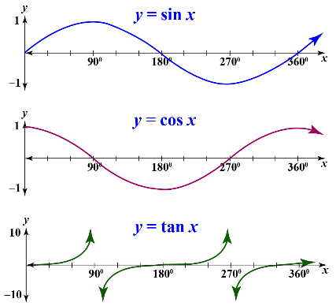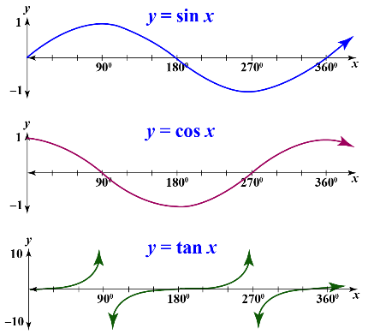

***Example 2*** Solve the equation sin *x*° = –0.5 for 0 ≤ *x* < 360.

***Solution*** The calculator gives sin–1(0.5) = –30.

This is usually called the *principal value* of the function sin–1.

To get a second solution you can use a graph.

By drawing the line *y* = -0.5 on the same set of axes as the graph of the sine curve, points of intersection can be identified in the range 0 ≤ *x* < 360.

*y* = –0.5

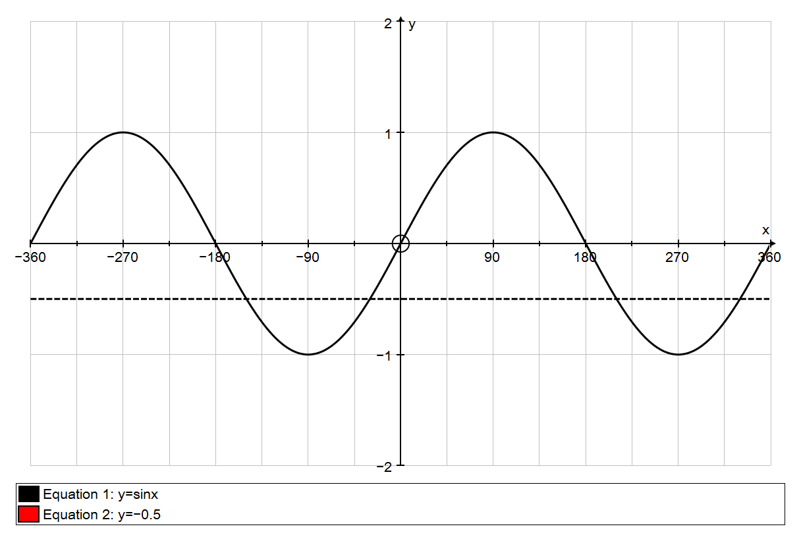

*x* = 210°

*x* = 330°

*x* = –30°

*y* = sin *x*

(The red arrows each indicate 30° to one side or the other.)

Hence the required solutions are 210° or 330°.

### Exercise 9

**Do not use a calculator in this exercise.**

**1** In this question *θ* is in the range 0 ≤ *θ* < 90.

(a) Given that , find the exact values of cos *θ* and tan *θ*.

(b) Given that , find the exact values of sin *θ* and cos *θ*.

(c) Given that , find the exact values of sin *θ* and tan *θ*.

**2** Find expressions, of the form *a* sin *θ* or *b* cos *θ*, for the sides labelled with letters in these triangles.

32°

*s*

*r*

5.6 cm

(a) (b)

20 cm

26°

*q*

*p*

10 cm

17°

*u*

*t*

(c) (d)

8.4 cm

20°

*v*

*w*

**3** Solve the following equations for 0 ≤ *x* < 360. Give your answers to the nearest 0.1°.

(a) sin *x*°= 0.9 (b) cos *x*°= 0.6 (c) tan *x*°= 2

(d) sin *x*°= –0.4 (e) cos *x*° = –0.5 (f) tan *x*° = –3