C-Tech Sport :
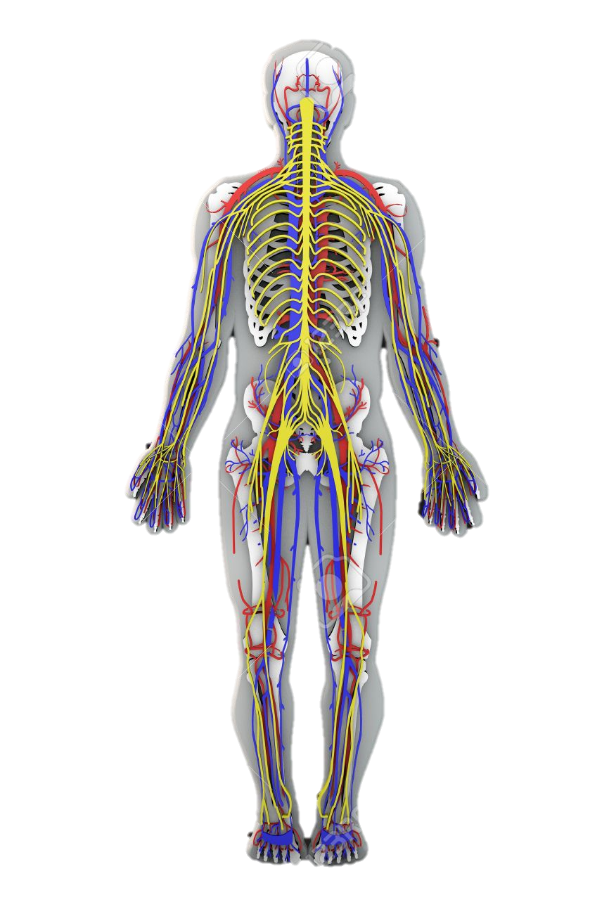
Bridging Unit
Name:

Congratulations for selecting C-Tech Sport!
We want you to be successful and what it takes to be successful at GCSEs is different from being successful at A-Levels. Although you have fewer subjects there are different skills at A-Level and the volume of work is greater because the depth and detail is more demanding. Bridging the Gap Work will reassure you that the subject you have selected is for you!
C-Tech Sport is like 3 subjects in one and sometimes it can feel like they do not connect! The level of knowledge of the body required for C-Tech Sport is comparable to A-Level Biology. Which is a big leap from GCSE. HOWEVER we are here to support you throughout your journey!
For every hour we give you in the classroom we expect it to be matched in your own time.

This series of tasks and activities are designed to give you an insight into OCR A-Level Physical Education. As part of the transition from year 11 AQA GCSE PE to OCR A-Level PE it is important to develop a greater understanding of certain aspects of the course which will help you over the next two years. Please complete the following booklet.
If you did not study GCSE PE in years 10 and 11 do not worry! A high percentage of the topics we will cover, have not been studied at GCSE so the information will be new to all students. It is however essential you are aware of the step up from key stage 4.

Equipment List:
Pen.
Pencil
Purple Pen
Highlighters
You will be provided with an exercise book but you are in charge of looking after it!
Resources:
Most pre-reading will be from this textbook.

Contacts:
Mr Davies: tdavies@wixamsacademy.co.uk
Mr Dummett: ddummett@wixamsacademy.co.uk

The C-Tech Sport Course:
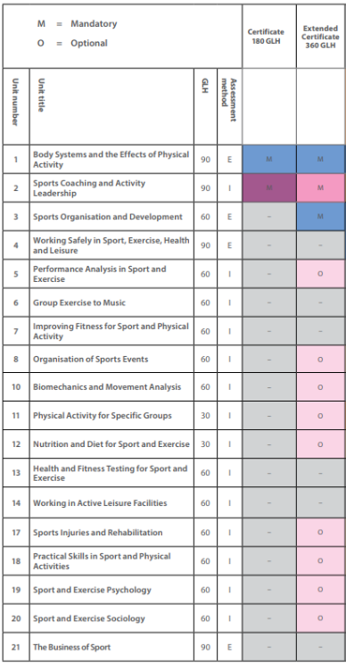

PRACTICAL:

Throughout the next two years of study you will be encouraged to enhance your involvement in sport and develop yourself as a performer or coach. It is therefore a prerequisite of the course that you are currently involved in competitive sport or have been and intend to return to competition in the near future. Even if you are injured you can keep a record of your treatment and rehabilitation which is an inevitable occurrence in a performer’s development
For C-Tech Sport you need to playing or coaching a sport regularly and competitively.
Please use the below to highlight what you currently do in terms of participating in sport and/or what upcoming sports you are planning on participating in:
Name

School

Sport

Team & League

Training Days & Times

Unit 1: Physiological Factors affecting performance. Add the definitions to the key terms!
Flexion
Extension
Abduction
Adduction
Horizontal Flexion
Horizontal Extension
Medial Rotation
Lateral Rotation
Circumduction
Dorsi Flexion
Plantar Flexion
Isotonic Contraction

Concentric Contraction
Eccentric Contraction
Isometric Contraction
Stroke Volume

Cardiac Output

Tidal Volume

Minute Ventilation

Arterioles
Adenosine Triphosphate (ATP)

Unit 1: Physiological Factors affecting performance.
Complete the table below. Select 2 sporting movement of your choice.

Sporting Example | Skeletal Movement | Bones Involved | Muscles Involved | Type of Contraction | Key Joint | Plane and Axis of Movement
Skeletal Movement:
Flexion Circumduction
Extension
Abduction
Adduction
Horizontal Flexion
Horizontal Extension
Medial and Lateral Rotation
Muscles:
Deltoid Iliopsoas
Latissimus Dorsi Gluteus Maximus
Pectoralis Major Gleteus Medius
Trapezius Gleteus Minimus Adductor Longus, Brevis, Magnus
Biceps Brachil Teres Minor
Triceps Brachii Soleus
Quadricep Group Rectus Femoris, Vastus Lateralis, Vastus Intermedius and Vastus Medialis
Contraction and Joints:
Isotonic ,Isometric ,Eccentric ,Concentric
Joints: Shoulder, Elbow, Wrist, Hip, Knee, Ankle

Unit 1: Physiological Factors affecting performance.
Energy Systems
Research and make notes on the following energy systems.
Adenosie Triphosphate (ATP)

ATP-PC (Phosphocreatine)

Glycolytic System

Aerobic System

Youtube has some fantastic videos!

Exercise Physiology
For this unit you must have an understanding of the function and importance of the components of a healthy, balanced diet:
- Carbohydrates
- Protein
- Fats
- Minerals
- Vitamins
- Fibre
- Water/Hydration

Ergogenic aids are substances or devices that enhance energy production, use or recovery and provide athletes with a competitive advantage.
Research examples of the following Ergogenic Aids:
Anabolic Steroids

Erythropoietin (EPO)

Human Growth Hormone (HGH)

Blood Doping

Intermittent Hypoxic Training (IHT)

Cooling Aids

Creatine

Biomechanics
Within Biomechanics, you will build upon your understanding of movement analysis: Planes of movement, axis of rotation and Lever Systems. It is imperative to have secured your understanding of the two.
For the pictures below identify the Plane of movement and Axis of Rotation
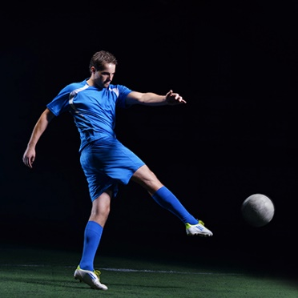 | a) | 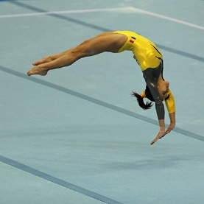 | d)
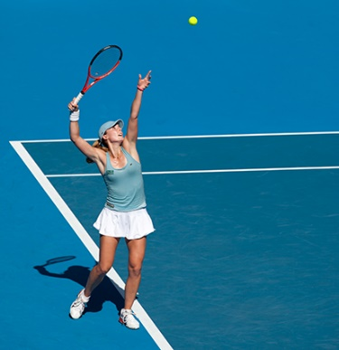 | b) |  | e)
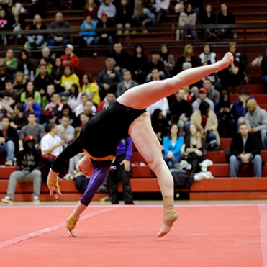 | c) | 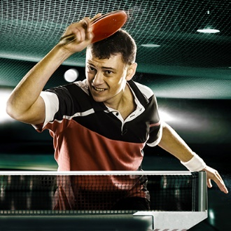 | f)
How can an athlete increase the velocity of their rotation? Use the example of an ice skater spinning to help you.

How can an athlete decrease the velocity of their rotation?- use the example of a high diver to help you.

Biomechanics
Within the biomechanics unit you will be looking into Newton’s laws of motion, forces and linear and angular motion. To prepare yourself for this fill in the definitions and any additional notes within the keyword bank.
Newton’s First Law: Inertia

Newton’s Second Law: Acceleration

Newton’s Third Law: Reaction
Velocity

Displacement

Momentum

Magnus Force

Psychological Factors Affecting Performance
https://www.youtube.com/watch?v=pbe25oKpqbs –Banduras Social Learning Theory Mister Simplify.
Watch the above video and make some notes
Questions to consider:
- Is social learning via direct or indirect instruction?

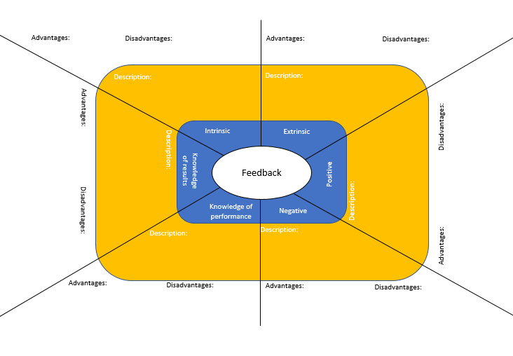
Psychological Factors Affecting Performance
Arousal:
- Arousal is the intensity of our emotion, motivation and behaviour
- It is the amount of drive to achieve
- It is the amount of psychological readiness

The effects of arousal can be both positive and negative on performance. There are three theories that we will explore to look at the effects of arousal.
-Drive Theory
-Catastrophe Theory
-Inverted U Theory

Optimal point of arousal
Low Arousal High
Low Performance High
Theory:
Low Arousal High
Low Performance High

Optimal arousal point
The Catastrophe
Low Arousal High
Low Performance High
Theory:

Task:
Research each of the Arousal Theories and write down below which theory most relates to you and explain why!
Theory:

