WJEC Level 3 Applied Diploma in Criminology
Sixth Form Bridging Work
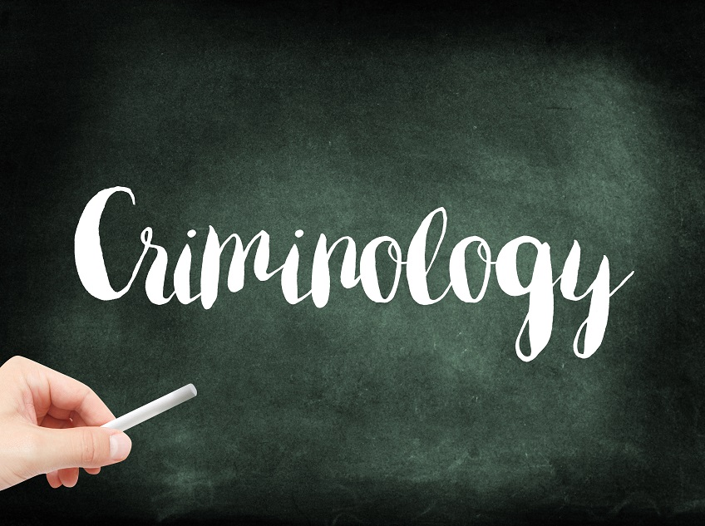

Name:

QUALIFICATION | Applied Certificate/Diploma in Criminology
Teacher Name | Miss S Rahman
Contact email | srahman@wixamsacademy.co.uk
Exam board | WJEC
Specification details | 601/6249/1 Applied Certificate  601/6248/X Applied Diploma
Textbooks/Revision guides to support your learning | 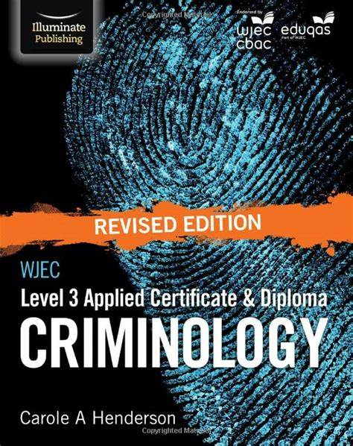  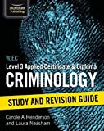  by Carole Henderson  Published by Illuminate

Please complete the weekly activities in this booklet in preparation for your studies in September. This will show us your commitment – Sixth Form study is hard work and there are no short cuts.

Good Luck!

Welcome to Applied Criminology

You have chosen a subject that combines elements of Psychology, Law and Sociology and that complements studies in Humanities. Each unit has an applied purpose which demands that learning is related to authentic case studies – this is the interesting bit! It will certainly ‘keep you on your toes’ and make you think in ways you couldn’t imagine. You will certainly have a very different outlook on society by the end of your course.

Overview of the course:
This is a two-year course. Units 1 and 2 completed in the first year comprise an 8-hour Controlled Assessment plus a formal examination. This is replicated in Year 2 with Units 3 and 4. You must complete and pass ALL units to gain the Diploma. The overall grades will be recorded on a scale A*-E.

Unit 1: Changing Awareness of Crime (Controlled Assessment)
Unit 2: Criminological Theories (Exam)
Unit 3: Crime Scene to Courtroom (Controlled Assessment)
Unit 4: Crime and Punishment (Exam)

Look at the specification for more detail about these topics. You can find this at: https://www.wjec.co.uk/media/21xjkr24/applied-diploma-in-criminology-specification-from-2015.pdf

You will be expected to know and understand the information covered, to be able to apply that knowledge and understanding and to be able to analyse and evaluate that knowledge and understanding.

Expectations of the course:

- Lessons consist of taking notes, group discussions, watching relevant documentaries, group work and PowerPoint presentations. Please bring a lever arch file to your first lesson – you’ll eventually need one for each unit.
- Homework consists of activities, note taking, wider reading, research, past exam questions, reviewing notes, and completing essays. You should spend a minimum of 5 hours per week on revision for criminology.
- Your progress will be reviewed on a regular basis. The review process will provide feedback at specific times throughout the year.
- You are expected to use the resources available to you in the library and are strongly encouraged to use libraries outside of school, not just the internet.
- Make a Criminology chat/WhatsApp for discussion.
- Your folders of notes will be checked on a regular basis to see if you are organised and up to date with your work. This is especially vital for Units 1 and 3 where you are allowed your folder with you for the controlled assessments.
- USE YOUR STUDY TIME AND BE PRO-ACTIVE.

Task 1

Tell me about yourself!

I may have taught some of you in the past but I’d love to know more about you and why you are taking Criminology. Please also tell me what you are expecting from this course and what other subjects you are taking.

I know it seems a long time away, but if you have any ideas what you’d like to do after sixth form – university/job/apprenticeship – please tell me about that too. Don’t worry if you’re still not sure!

Finally this is your chance to tell me anything you want me to know. For example, you like working in groups, you hate reading aloud or you struggle with eyesight and need to be closer to the board.

Looking forward to hearing from you!

Task 2

Read the specification carefully https://www.wjec.co.uk/qualifications/criminology-level-3/#tab_keydocuments and make a note below of the sections there are to each unit:

Changing Awareness of Crime
…………………………………………………………..………...…………………………………………..
.…………………………………………………………….………………………………….………………
…………………………………………………………..…………………….............................................

Criminological Theories
…………………………..……………………………………………………..……………………………...
……………………………………………………….………………………………………………………..
…………………………………………………………..……………………...……………………………..

Crime Scene to Courtroom
………………………………………………………………………………………………….…………..
……………………………………………………………….……………………………………………..
………………………………………………………………….…………………………………………..

Crime and Punishment in Society
……………………………………………………………………………………………………………..
…………………………………………………………….……………………………………………….
……………………………………………………………………………..………………………………

Task 3
Watch something from the list below and complete a report on the next page:
Watching List - Criminology
- Any documentaries, including Panorama, Louis Theroux, Stacey Dooley, Mind of a Murderer etc
- Black Mirror series (Netflix)
- Goodfellas
- The Godfather (part 2 is the best)
- Legend
- McMafia (previously BBC i-player)
- Freedom Writer’s Diary
- Dangerous Minds
- Chernobyl (drama)
- When They See Us (Netflix)
- The Society (Netflix)
- Blood Diamond
- Ted Talks/Crime/Criminal Justice
- Orange is the New Black (Netflix)
- The Innocence Files (Netflix)
- Cold Case Files (Netflix)
- I Am A Killer (Netflix)
- When They See Us Now – Oprah Winfrey (Netflix)
- The Stanford Prison Experiment (Youtube)
- The Push – Derren Brown (Netflix)
- MacIntyre Undercover: The Chelsea Headhunters (Youtube)
- The Shawshank Redemption
- The Green Mile

……………………………………………………………………………………………………………..
…………………………………………………………….……………………………………………….
……………………………………………………………………………..………………………………
……………………………………………………………………………………………………………..
…………………………………………………………….……………………………………………….
……………………………………………………………………………..………………………………
……………………………………………………………………………………………………………..
…………………………………………………………….……………………………………………….
……………………………………………………………………………..………………………………
……………………………………………………………………………………………………………..
…………………………………………………………….……………………………………………….
……………………………………………………………………………..………………………………
……………………………………………………………………………………………………………..
…………………………………………………………….……………………………………………….
……………………………………………………………………………..………………………………
……………………………………………………………………………………………………………..
…………………………………………………………….……………………………………………….
……………………………………………………………………………..………………………………
……………………………………………………………………………………………………………..
…………………………………………………………….……………………………………………….
……………………………………………………………………………..………………………………
……………………………………………………………………………………………………………..
…………………………………………………………….……………………………………………….
Task 4
Watch the following clip and jot down 5 things that tell you what Criminology is.

https://www.youtube.com/watch?v=tdaqqlFQdTE

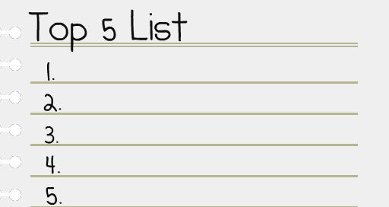

Task 5

What’s the difference between a crime and deviance?

A crime can be defined as ……………………………………………………………….

…………………………………………………………………………………………………..

Deviance is …………………………………………………………………………………..

…………………………………………………………………………………………………..

Examples of crimes are: …………………………………………………………………...

…………………………………………………………………………………………………..

Examples of deviance are: ……………………………………………………………….

…………………………………………………………………………………………………..

Task 6

Think of 3 different ways society has changed over the last 100 years. Try to be specific about the change e.g. homosexuality is no longer illegal.

- ……………………………………………………………………………………………..

- ……………………………………………………………………………………………..

- ……………………………………………………………………………………………..

Now, name 3 ways in which British society is different to another (America, Italy etc.)

- ……………………………………………………………………………………………

…………………………………………………………………………

- ……………………………………………………………………..

……………………………………………………………………………

- ……………………………………………………………………………………………

…………………………………………………………………………………………………

Task 7

Famous faces and their crimes or deviance? Match the famous face to the act of crime or deviance.

- Trespassing and damage of property leading to loss of owner’s income
- Arrested for possession and being under the influence of drugs, possession of an unloaded gun and trespassing
- Arrested for protesting outside the South African embassy against unfair treatment of Black people in South Africa
- Arrested for assault, driving under the influence of drugs, driving whilst license was suspended
- Avoiding paying £20 million in tax that would help to pay for the NHS, Welfare and Schools in this country
- Driving under the influence of alcohol and causing a collision injuring two other people

I’ll let you know the answers when we return in September!

Task 8
Research the following types of crime. You need to understand the definition of the type of crime, the typical offender and the typical victim.

- State Crime

Definition……………………………...............................................................................

.......................................................................................................................................

Typical Offender …………………………………………………………………………….

Typical Victim …………………………………………………………………………......

Example: ……………………………………………………………………………………

…………………………………………………………………………………………………

…………………………………………………………………………………………………

…………………………………………………………………………………………………

…………………………………………………………………………………………………

- White Collar Crime

Definition……………………………...............................................................................

.......................................................................................................................................

Typical Offender …………………………………………………………………………….

Typical Victim ………………………………………………………………………….........

Example: ……………………………………………………………………………………...

…………………………………………………………………………………………………

…………………………………………………………………………………………………

…………………………………………………………………………………………………

…………………………………………………………………………………………………

- Moral Crimes

Definition……………………………...............................................................................

.......................................................................................................................................

Typical Offender …………………………………………………………………………….

Typical Victim ………………………………………………………………………….........

Example: ……………………………………………………………………………………...

…………………………………………………………………………………………………..

…………………………………………………………………………………………………..

…………………………………………………………………………………………………

…………………………………………………………………………………………………

- Technological Crimes

Definition……………………………...............................................................................

.......................................................................................................................................

Typical Offender …………………………………………………………………………….

Typical Victim ………………………………………………………………………………

Example: ……………………………………………………………………………………...

…………………………………………………………………………………………………

…………………………………………………………………………………………………

…………………………………………………………………………………………………

…………………………………………………………………………………………………

- Hate Crime

Definition……………………………...............................................................................

.......................................................................................................................................

Typical Offender …………………………………………………………………………….

Typical Victim …………………………………………………………………………......

Example: ……………………………………………………………………………………...

…………………………………………………………………………………………………..

…………………………………………………………………………………………………

…………………………………………………………………………………………………

…………………………………………………………………………………………………

Task 9

As part of your course you will have to look at campaigns that have caused a change in the law. You will also have to plan your own campaign.
Conduct research on the following campaigns. Find out what the original crime was that sparked the campaign; what the aim of the campaign was; what methods were used (eg. TV interviews, advertising, wristbands, petitions, T-shirts etc) and whether the campaign was successful.

Sarah’s Law
The Double Jeopardy Law
Dignity in Dying
Snowdrop Campaign
Slow Down for Bobby
Anti-Foxhunting Campaign

Task 10
Nature vs Nurture – The Big Debate
There are many ways of explaining why certain people do things in certain ways. For example, biologists think that people behave as they do because they are controlled by nature. This is known as Nature theory. Humans are compared to animals and seen to act on instinct.

Sociologists believe that people behave as they do because they are taught how to behave. For example, the sociologist Michael Haralambos states, ‘Human beings learn their behavior and use their intelligence whereas animals simply act on instinct.’ This is known as Nurture theory. Nurture means the way you are brought up. It is also a reference to socialization, the lifelong process by which we learn our culture, values, norms and how to behave.

Research the childhood backgrounds of any notorious serial murderers such as Fred West or Harold Shipman. The focus should be on life history and not subsequent crimes. Thinking about what you have read about ‘Nature and Nurture’, which explanation could account for their criminal behaviour?

