June 2024

Year 7 Subject Meetings Thursday 27th June 2024

Dear Parents/carers,

We are excited to announce that bookings for the Year 7 Subject Meetings will be open from 11th June at 12.00pm. Meetings will take place on Thursday 27th June from 2.30pm until 7.30pm. The school will close at 1.45pm after period 4 when buses will collect students. Hot food will be available at break and sandwiches will be available at 1.45pm at the end of the school day.

Subject teachers are looking forward to discussing the students end of year reports and how we can support student progress moving forward. If you wish to discuss pastoral issues and would like to speak to the Head of Year, Mrs J Kavanagh, please contact her via her email address jkavanagh@wixamsacademy.co.uk.

Following staff and parent feedback all meetings will be on site only. You will be able to choose your own appointment times with your child’s teachers and will receive emails confirming your appointments. There will only be one appointment for each teacher, so if your child is taught more than one subject by a teacher all discussions will take place in this slot.
The booking link can be accessed via the school website: This link is located in the ‘Parent Tab’ in the parents evening file.
https://wixamsacademy.co.uk/parents-carers/parents-consultation-events/

Appointments will last a maximum of 6 minutes. To maximise the time, you may wish to email longer questions to your child’s teacher prior to the meeting. After the meeting, if you wish a further discussion, please email the subject teacher and they will get back to you as soon as possible.

Detailed instructions on how to use the booking system are given on the reverse of this letter, in the parent guide. More information about how to book an appointment can also be found in the link below:
https://wixamsacademy.co.uk/wp-content/uploads/sites/2/2022/03/Parent-guide-to-virtual-meetings.pdf

On Thursday, 27th June school will finish at 1:35pm for all students. Students will have completed all lessons by this time.

We look forward to seeing you.

Yours faithfully

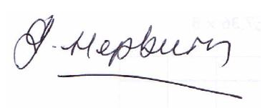

Mrs Jacqueline Hepburn
Assistant Headteacher

