Welcome
Welcome to the Sociology A Level course at Wixams Academy! This bridging booklet will prepare you for your course start in September. Some of you may have studied GCSE Sociology, whilst some may not have. It doesn’t matter about prior knowledge; we will start from ground zero. However, if you have prior knowledge, I ensure you that you will be stretched, challenged, and exposed to very high level material and analysis. Completing this booklet will soften the blow of hitting the ground running as you start your KS5 journey.
Sociology is the study of society, something we all and participate in and experience. How we interact with people, how our identities are shaped and how we are impacted according to our identities and the social groups we belong to, are subject to our interrogation. Studying sociology will open many doors, in your future and in your mind.
You will develop knowledge on the diversity of families and households; demography; the British education system and the factors affecting achievement (such as class, gender, and ethnicity); the causes of crime, definitions of deviance, which social groups are more likely to be punished for crimes and why; and globalisation and its implications on the development of countries around the world. One of the main issues we study in sociology is inequality and how that permeates through issues such as crime and education, across nations that are considered developed and developing, and within family structures.
You will craft your ability to formulate convincing and balanced arguments based on sociological knowledge, research, and theory. By learning the various perspectives of sociology, you will learn to argue various points of view on specific and meaningful topics.
All completed work from this booklet must be handed in the first day back. Tasks are in bold.

“I often say that sociology is a martial art, a means of self-defence. Basically, you use it to defend yourself, without having the right to use it for unfair attacks.” – Pierre Bourdieu

What will you study?
- Families and households
- Education
- Research methods
- Sociological theory
- Crime and deviance
- Global development
Some questions you may encounter in A-level sociology:
- Why are working class boys one of the most underachieving social groups?
- What constitutes a family unit? Can a dog be a member of the family? Can you live apart and be considered a family?
- What has the impact been of feminism on the family? How has this affected the structure of society?
- Why are some ethnic minorities disproportionately represented in the prison system? How is policing affected by these trends? Are the statistics used in creating these trends a reasonable way to view crime?
- How much power do multi-national corporations have? Should governments curtail the powers of these corporations for committing human rights abuses, even if it isn’t illegal?

What skills will you develop?
This is an academic and essay-based course. You will be formally assessed on your essay writing, however there will be ample opportunity to engage in fruitful discussions, create projects and social action research on the numerous topics that we cover. A key skill you will develop is how to construct, analyse and critique a sociological argument.
Alongside these written skills, you will develop analytical skills that allow you to weigh up the strengths and weaknesses of statements of society, sociological contributions, statements, research data, and much more.
Most importantly, your critical and evaluative skills will be nurtured. In the final exams, a proportion of your assessed material will be analysis and evaluation. In order to achieve the highest grades, you must be critical and evaluative throughout.
You will learn how to compare various factors that may influence a structural problem found within one of the interesting subjects we over. For instance, how ethnic minorities and working-class pupils are disadvantaged by the marketisation of education due to the interrelationship between formula funding, catchment areas, league tables and what is conceptualised as an educational triage, creating what is known in Sociology as ‘the A-C economy’ (now it may be known as 9-5 economy). All these factors interplay with one another but ultimately create a vastly unequal education system, where sink schools attract pupils from deprived backgrounds and are underfunded, therefore perpetuating class inequalities.

Quick task
The above paragraph is a concise snippet of an area of the Education topic. Your task is to research this topic and the key words that are littered throughout. Write a short paragraph on your findings. Consider the following:
- What process of marketisation have you focussed on (you’re not confined to just one)
- Why is the social group you’ve chosen disadvantaged?
- Who introduced this social policy?
- Has the policy been effective in other ways?

Assessment
You will sit three exams at the end of Year 13. The questions are essay based. We are using the AQA exam board.
Paper 1: Education with Theory and Methods | Paper 2: Topics in Sociology | Paper 3: Crime and  Deviance with Theory and Methods
Education  - Role and functions of the education system  - Differential educational achievement  - Relationships and processes both internal and external to school  - Educational policy | Families and households  - Relationship of family to social structure and social change  - Changing patterns of marriage, cohabitation, separation, divorce  - Sociology of personal life and  family diversity  - Gender roles, domestic labour and power relationships  - Nature of childhood  - Demographic trends in the UK since 1900 | Crime and Deviance  - Crime, deviance, social control and social order  - Social distribution of crime  - Globalisation and crime  - Crime control, surveillance, prevention and punishment, victimology, role of  justice system
Theory and Methods  - Quantitative and qualitative methods  - Sources of data  - Research perspectives  - Theoretical, practical and ethical considerations  - The scientific method  - Social policy | Global Development  - Development, underdevelopment, and global inequality  - Cultural, political, and economic globalisation  - Role of transnational corporations, nongovernmental organisations  - Aid and trade, industrialisation, urbanisation, the environment, war  and conflict  - Employment,  education, health, gender, demography | Theory and Methods  - Quantitative and qualitative methods  - Sources of data  - Research perspectives  - Theoretical, practical and ethical considerations  - The scientific method  - Social policy

Getting Started

Perspective research activity
In Sociology there are various theories we use to analyse and evaluate sociological points and information. Read, research, and watch videos in order to familiarise yourself with each theory. Create a table with the basic characteristics and attributes of each theory.
- Functionalists
- Marxists
- Feminists
- Postmodernists
- The New Right

Theory | Resource used | Characteristics/attributes
Functionalists
Marxists
Feminists
Postmodernists
The New Right

Key words task
Sociology is littered with key terms and a large part of your essay craft will depend on your appropriate use of these key terms. You are marked on your use of them or lack thereof. See below for a short collection of key terms. Please find their definitions in the context of sociology.

Socialisation  Paradigm  Norms  Values  Social control  Sanctions  Verstehen  Subculture | Multiculturalism  Consumer culture  Global culture  Discrimination  Inequality  Agency  Structure  Status

Interpretation task:
Interpret the below image. What do you think it is implicating about the education system?
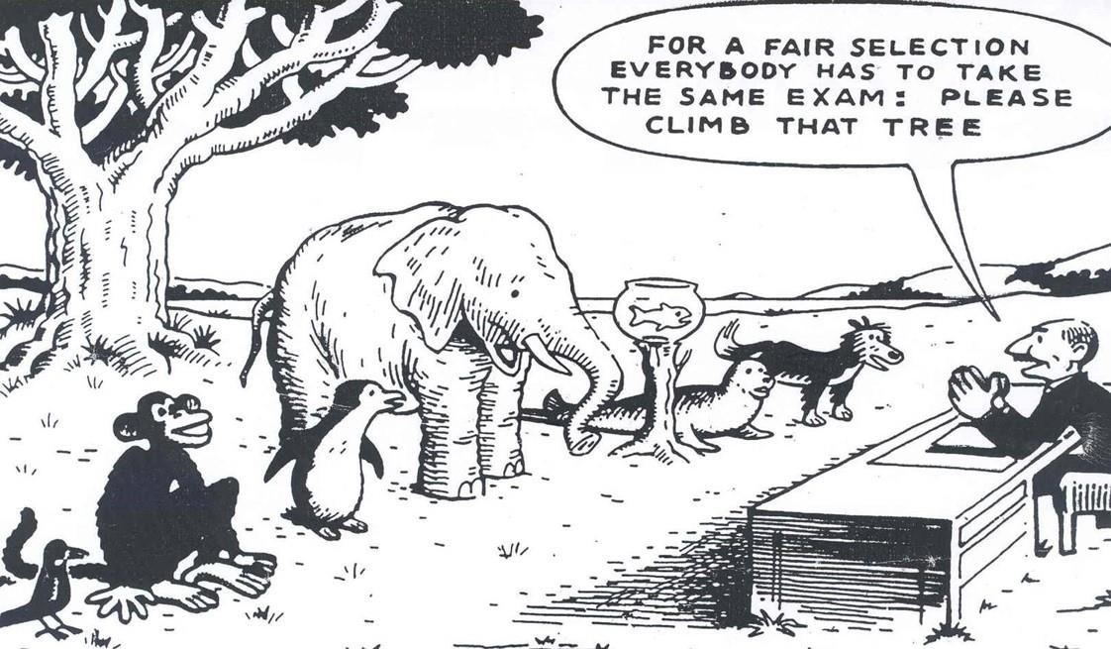

Watch these videos by educator Ken Robinson. Take notes and quotes from them.
https://www.youtube.com/watch?v=iG9CE55wbtY&t=70s&ab_channel=TED https://www.youtube.com/watch?v=zDZFcDGpL4U&ab_channel=RSA

Research task
Look on the government’s website to find official statistics about educational achievement by ethnic group and interpret the data.
See below for three example explanations for underachievement, both internal and external:
- Material deprivation
- Labelling
- Cultural deprivation
Find out what each of these is and explain how this may relate to the data you have interpreted. Create a table that looks like the one below and complete it.
Ethnicity | Data | Explanation | Thoughts

Consider:
- What are your thoughts on the relationship between these factors and ethnicity, using the data as a reference?
- Why is the explanation you have chosen more convincing than the others?
- What issues may there be with the research method? (You do not have to do extensive research on research methods, but it is good to have a look at jot down a few comments on this).

Research task
Examine these sources and take note of their key points. Copy this style table into your note to hand in.
Afterwards, write a summary (500 words maximum) as to why the education system in Britain is considered to be unfair/unequal.
Source | Key points
Article: Diane Reay explaining the unequal treatment of working class children in education

Report (can just read the executive summary, more if you wish): The impact of attitudes and expectations on educational attainment
Too Poor for Posh School?
Clip: Should we abolish private schools?
Clip: Living in poverty
Child Poverty in Britain
Breadline Kids

Gender
Gender is different from sex. Gender is not biological. It is a social construct that we perform every day. It has evolved throughout history and through cultures. It moulds us, and we mould it. In sociology we study the roles and norms that are attached to genders.
Answer these following questions.
- List three types of behaviour that families socialise girls to have

- List three types of behaviour that families socialist boys to have

- Give two ways that schools have different expectations of boys than girls

There are three main strands of feminism in Sociology
- Liberal feminist
- Marxist feminist
- Radical feminist
Research each strand and decide which one makes most sense to you.

Research and resource task
In the taster session there were six case studies that were on offer for discussion. These included:
- Should we abolish private schools?
- Should we abolish police?
- Grenfell Tower
- Why is Africa underdeveloped?
- 2011 riots
- Ukraine War
Choose one and create a PowerPoint presentation (6 minutes maximum). You should include the details of the event, the causes, the consequences, and a sociological explanation (I do not expect this to be thorough as you have not yet learned theories).

Staying informed
Staying up to date on current affairs is important to succeed in A level Sociology. You must be able to recall novel and contemporary information, research issues and stay informed. It’s important to get in the habit of following current affairs. If you start these habits, they will become second nature once the course begins. There are no tasks here, but it is advised you browse these resources and begin reading around your interests that are relevant to Sociology (see reading list).

Magazines both online and paper
The Spectator
Private Eye
New Statesmen
The Economist
Tribune

Newspapers
The Guardian
The Daily Telegraph
The Financial Times
Morning Star

Television
The News: Channel 4 News, BBC News, Good Morning Britain, The One Show,
Other Political shows: Have I Got News For You, Newsnight, Question Time, Peston, The Andrew Marr Show
News Channels: Sky News, BBC News, Al Jazeera, Euronews, GB News

YouTube
There are so many YouTube videos that can be beneficial for your understanding of Sociology. At the same time, there are numerous that may make unsubstantiated propositions and arguments, oftentimes not backed up by evidence. As your skills develop, you will be able to critically analyse these forms of media.
Are They Gay?
Ted x Talks

Twitter
Twitter can be one of the most powerful tools in staying informed. Most news sources have accounts, as well as various non-official accounts spreading information around the world. Be careful – some tweets can be unsubstantiated, make sure you fact-check and cross-reference! Similarly, users are free to twist information to suit their ideology of agenda. Again, this is a skill that you will nurture throughout the course.

Podcasts
Rev Left Radio (also on spotify)
Sociology Ruins Everything

TV, film, and documentaries.
Try to watch Love Island and see the patriarchal values in both the male and female contestants.
Watch Slavoy Zizek’s A Perverts Guide to Ideology. Or you can find short snippets like this on YouTube.
The Social Dilemma documentary.
Point and Shoot documentary.
VICE documentaries.
McMafia
War Dogs

Reading list
The New Poverty by Stephen Armstong
The Violence of Austerity by Cooper and Whyte
Freakonomics (also a film and podcast) by Dubner and Levitt
Discipline and Punish by Foucault
The Communist Manifesto by Marx and Engels
Imperialism, the Highest Stage of Capitalism by Lenin
23 Things They Don’t Tell You About Capitalism by Ha Joon Chang
The Will To Change by bell hooks
The Ways of the World by David Harvey
Essential Concepts in Sociology by Giddens and Sutton

